|  |
| --- |
| Citizen Survey Results (FULL) |
|  |
| January 31  Community Development  Authored by: Adrian Ackerman |

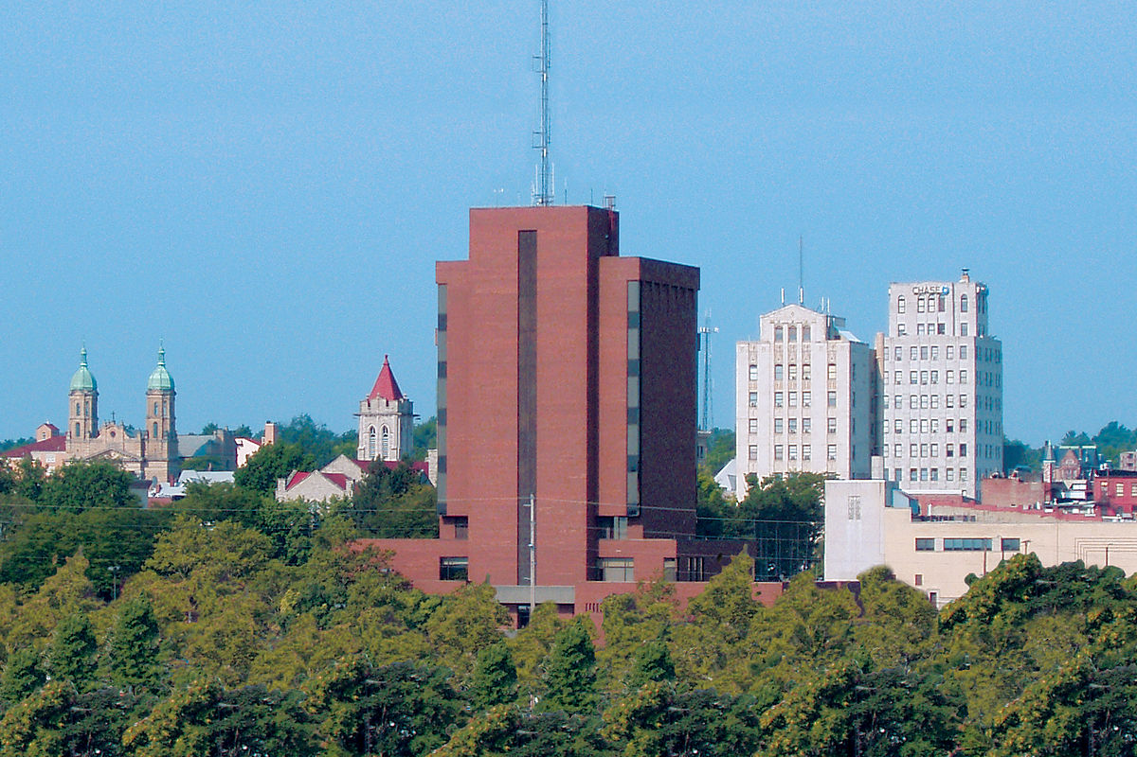

# Portions of the results have been edited due to personal information or inappropriate content

# 

# U:\Survey Results\2021\Citizen\Q2.PNG

# U:\Survey Results\2021\Citizen\Q3.PNG

# U:\Survey Results\2021\Citizen\Q4.PNG

# U:\Survey Results\2021\Citizen\Q5.PNG

# U:\Survey Results\2021\Citizen\Q6.PNG

# U:\Survey Results\2021\Citizen\Q7.PNG

# U:\Survey Results\2021\Citizen\Q8.PNG

# U:\Survey Results\2021\Citizen\Q9.PNG

# U:\Survey Results\2021\Citizen\Q10.PNG

# U:\Survey Results\2021\Citizen\Q11.PNG

# U:\Survey Results\2021\Citizen\Q12.PNG

# U:\Survey Results\2021\Citizen\Q13.PNG

# U:\Survey Results\2021\Citizen\Q14.PNG

# U:\Survey Results\2021\Citizen\Q15.PNG

# U:\Survey Results\2021\Citizen\Q16.PNG

# U:\Survey Results\2021\Citizen\Q17.PNGU:\Survey Results\2021\Citizen\Q18.PNG

# U:\Survey Results\2021\Citizen\Q19.PNG

# U:\Survey Results\2021\Citizen\Q19b.PNG

# U:\Survey Results\2021\Citizen\Q19a.PNG

# 

# U:\Survey Results\2021\Citizen\Q19d.PNG

# U:\Survey Results\2021\Citizen\Q19e.PNG

# U:\Survey Results\2021\Citizen\Q20.PNG

# U:\Survey Results\2021\Citizen\Q20a.PNG

# U:\Survey Results\2021\Citizen\Q20b.PNG

# U:\Survey Results\2021\Citizen\Q20c.PNG

# U:\Survey Results\2021\Citizen\Q20d.PNG

# U:\Survey Results\2021\Citizen\Q21.PNG

# U:\Survey Results\2021\Citizen\Q22.PNG

# U:\Survey Results\2021\Citizen\Q23.PNG

# U:\Survey Results\2021\Citizen\Q24.PNG

# U:\Survey Results\2021\Citizen\Q25.PNG

# U:\Survey Results\2021\Citizen\Q26.PNG

# U:\Survey Results\2021\Citizen\Q26a.PNG

# U:\Survey Results\2021\Citizen\Q26b.PNG

# U:\Survey Results\2021\Citizen\Q26c.PNG

# U:\Survey Results\2021\Citizen\Q26d.PNG

# U:\Survey Results\2021\Citizen\Q27.PNG

# U:\Survey Results\2021\Citizen\Q28.PNG

# U:\Survey Results\2021\Citizen\Q29.PNG

# U:\Survey Results\2021\Citizen\Q29a.PNG

# U:\Survey Results\2021\Citizen\Q29b.PNG

# U:\Survey Results\2021\Citizen\Q29c.PNG

# U:\Survey Results\2021\Citizen\Q29d.PNG

# END