CR-05 - Goals and Outcomes
Progress the jurisdiction has made in carrying out its strategic plan and its action plan. 91.520(a)
This could be an overview that includes major initiatives and highlights that were proposed and executed throughout the program year.

The City of Mansfield receives Community Development Block Grant (CDBG) and HOME funds directly from The Department of Housing and Urban Development's entitlement funds.
2019 Program Year Allocations were as follows:
CDBG 2019 B-19-MC-39-0017 $854,831
HOME 2019 M-19-MC-39-0221 $252,424
The City of Mansfield's Community Development Department has focused its efforts on housing rehabilitation within the City. The first area of need is emergency rehabilitation. In said program, the Department seeks to repair as many as possible components in a resident's home that threaten the health and safety of the owner occupants. Second, the City has a full rehabilitation program which is focused to bring a residential structure up to the standard of the Ohio Residential Building Code and Ohio Residential Rehabilitation Standard (RRS).
The City also continued working with sub-recipients funding transportation, emergency subsistence payments, and after school programs to benefit low and moderate income residents.
The City also continued work on the identified West-End target area, formulating an architectural plan to increase safe pedestrial travel and increase housing desireablility.
For year one (2019) of the Consolidated Plan (2019-2023), the City continued to make headway after experiencing a large amount of staff turnover. The City worked to ensure program monies were spent in a responsible manner and in accordance with Federal regulations. 100% of the 2019 program activities benefited low to moderate income residents of Mansfield.

Comparison of the proposed versus actual outcomes for each outcome measure submitted with the consolidated plan and explain, if applicable, why progress was not made toward meeting goals and objectives. 91.520(g)
Categories, priority levels, funding sources and amounts, outcomes/objectives, goal outcome indicators, units of measure, targets, actual outcomes/outputs, and percentage completed for each of the grantee’s program year goals.

Goal | Category | Source / Amount | Indicator | Unit of Measure | Expected – Strategic Plan | Actual – Strategic Plan | Percent Complete | Expected – Program Year | Actual – Program Year | Percent Complete
Homelessness Prevention | Homeless  Non-Housing Community Development | CDBG: $ / HOME: $ | Homeless Person Overnight Shelter | Persons Assisted | 500 | 0 | 0.00%
Homelessness Prevention | Homeless  Non-Housing Community Development | CDBG: $ / HOME: $ | Homelessness Prevention | Persons Assisted | 50 | 0 | 0.00% | 10 | 0 | 0.00%
Homelessness Prevention | Homeless  Non-Housing Community Development | CDBG: $ / HOME: $ | Housing Code Enforcement/Foreclosed Property Care | Household Housing Unit | 5 | 0 | 0.00%
Homelessness Prevention | Homeless  Non-Housing Community Development | CDBG: $ / HOME: $ | Other | Other | 1 | 0 | 0.00% | 1 | 0 | 0.00%
Improve & Expand Neighborhood Facilities | Homeless  Non-Homeless Special Needs  Non-Housing Community Development | CDBG: $ / HOME: $ | Public Facility or Infrastructure Activities other than Low/Moderate Income Housing Benefit | Persons Assisted | 100 | 0 | 0.00% | 100 | 0 | 0.00%
Improve & Expand Neighborhood Facilities | Homeless  Non-Homeless Special Needs  Non-Housing Community Development | CDBG: $ / HOME: $ | Public Facility or Infrastructure Activities for Low/Moderate Income Housing Benefit | Households Assisted | 100 | 0 | 0.00% | 100 | 0 | 0.00%
Improve & Expand Neighborhood Facilities | Homeless  Non-Homeless Special Needs  Non-Housing Community Development | CDBG: $ / HOME: $ | Public service activities other than Low/Moderate Income Housing Benefit | Persons Assisted | 0 | 0
Improve & Expand Neighborhood Facilities | Homeless  Non-Homeless Special Needs  Non-Housing Community Development | CDBG: $ / HOME: $ | Overnight/Emergency Shelter/Transitional Housing Beds added | Beds | 0 | 0
Improve & Expand Neighborhood Facilities | Homeless  Non-Homeless Special Needs  Non-Housing Community Development | CDBG: $ / HOME: $ | Homelessness Prevention | Persons Assisted | 0 | 0
Improve & Expand Neighborhood Facilities | Homeless  Non-Homeless Special Needs  Non-Housing Community Development | CDBG: $ / HOME: $ | Other | Other | 1 | 0 | 0.00% | 1 | 0 | 0.00%
Improve, Maintain, and Expand Affordable Housing | Affordable Housing  Homeless | CDBG: $ / HOME: $ | Homeowner Housing Rehabilitated | Household Housing Unit | 60 | 1 | 1.67% | 30 | 35 | 116.67%
Improve, Maintain, and Expand Affordable Housing | Affordable Housing  Homeless | CDBG: $ / HOME: $ | Direct Financial Assistance to Homebuyers | Households Assisted | 20 | 0 | 0.00% | 6 | 0 | 0.00%
Improve, Maintain, and Expand Affordable Housing | Affordable Housing  Homeless | CDBG: $ / HOME: $ | Homeless Person Overnight Shelter | Persons Assisted | 0 | 0
Improve, Maintain, and Expand Affordable Housing | Affordable Housing  Homeless | CDBG: $ / HOME: $ | Other | Other | 1 | 0 | 0.00% | 1 | 0 | 0.00%
Increase Economic Opportunities | Non-Housing Community Development  any | CDBG: $ / HOME: $ | Facade treatment/business building rehabilitation | Business | 5 | 0 | 0.00%
Increase Economic Opportunities | Non-Housing Community Development  any | CDBG: $ / HOME: $ | Jobs created/retained | Jobs | 4 | 0 | 0.00%
Increase Economic Opportunities | Non-Housing Community Development  any | CDBG: $ / HOME: $ | Businesses assisted | Businesses Assisted | 4 | 0 | 0.00% | 2 | 0 | 0.00%
Increase Economic Opportunities | Non-Housing Community Development  any | CDBG: $ / HOME: $ | Other | Other | 1 | 0 | 0.00% | 1 | 0 | 0.00%
Planning and Program Administration |  | CDBG: $ / HOME: $ | Other | Other | 1 | 1 | 100.00% | 1 | 0 | 0.00%
Provide Needed Public Services | Affordable Housing  Public Housing  Homeless  Non-Homeless Special Needs  Non-Housing Community Development | CDBG: $ / HOME: $ | Public service activities other than Low/Moderate Income Housing Benefit | Persons Assisted | 400 | 3267 | 816.75% | 500 | 3293 | 658.60%
Provide Needed Public Services | Affordable Housing  Public Housing  Homeless  Non-Homeless Special Needs  Non-Housing Community Development | CDBG: $ / HOME: $ | Public service activities for Low/Moderate Income Housing Benefit | Households Assisted | 400 | 26 | 6.50%
Provide Needed Public Services | Affordable Housing  Public Housing  Homeless  Non-Homeless Special Needs  Non-Housing Community Development | CDBG: $ / HOME: $ | Other | Other | 1 | 0 | 0.00% | 1 | 0 | 0.00%
Revitalize Neighborhoods | Affordable Housing  Non-Homeless Special Needs  Non-Housing Community Development | CDBG: $ / HOME: $ | Public Facility or Infrastructure Activities other than Low/Moderate Income Housing Benefit | Persons Assisted | 800 | 45266 | 5,658.25% | 10 | 45266 | 452,660.00%
Revitalize Neighborhoods | Affordable Housing  Non-Homeless Special Needs  Non-Housing Community Development | CDBG: $ / HOME: $ | Public Facility or Infrastructure Activities for Low/Moderate Income Housing Benefit | Households Assisted | 800 | 0 | 0.00% | 100 | 0 | 0.00%
Revitalize Neighborhoods | Affordable Housing  Non-Homeless Special Needs  Non-Housing Community Development | CDBG: $ / HOME: $ | Public service activities other than Low/Moderate Income Housing Benefit | Persons Assisted | 0 | 0 |  | 500 | 0 | 0.00%
Revitalize Neighborhoods | Affordable Housing  Non-Homeless Special Needs  Non-Housing Community Development | CDBG: $ / HOME: $ | Public service activities for Low/Moderate Income Housing Benefit | Households Assisted | 0 | 0 |  | 1000 | 0 | 0.00%
Revitalize Neighborhoods | Affordable Housing  Non-Homeless Special Needs  Non-Housing Community Development | CDBG: $ / HOME: $ | Facade treatment/business building rehabilitation | Business | 5 | 0 | 0.00% | 1 | 0 | 0.00%
Revitalize Neighborhoods | Affordable Housing  Non-Homeless Special Needs  Non-Housing Community Development | CDBG: $ / HOME: $ | Brownfield acres remediated | Acre | 1 | 0 | 0.00%
Revitalize Neighborhoods | Affordable Housing  Non-Homeless Special Needs  Non-Housing Community Development | CDBG: $ / HOME: $ | Homeowner Housing Rehabilitated | Household Housing Unit | 25 | 50 | 200.00%
Revitalize Neighborhoods | Affordable Housing  Non-Homeless Special Needs  Non-Housing Community Development | CDBG: $ / HOME: $ | Homeless Person Overnight Shelter | Persons Assisted | 0 | 0 |  | 40 | 0 | 0.00%
Revitalize Neighborhoods | Affordable Housing  Non-Homeless Special Needs  Non-Housing Community Development | CDBG: $ / HOME: $ | Businesses assisted | Businesses Assisted | 0 | 0 |  | 2 | 0 | 0.00%
Revitalize Neighborhoods | Affordable Housing  Non-Homeless Special Needs  Non-Housing Community Development | CDBG: $ / HOME: $ | Buildings Demolished | Buildings | 5 | 0 | 0.00% | 1 | 0 | 0.00%
Revitalize Neighborhoods | Affordable Housing  Non-Homeless Special Needs  Non-Housing Community Development | CDBG: $ / HOME: $ | Housing Code Enforcement/Foreclosed Property Care | Household Housing Unit | 100 | 0 | 0.00% | 500 | 0 | 0.00%
Revitalize Neighborhoods | Affordable Housing  Non-Homeless Special Needs  Non-Housing Community Development | CDBG: $ / HOME: $ | Other | Other | 1 | 0 | 0.00% | 1 | 0 | 0.00%
Table 1 - Accomplishments – Program Year & Strategic Plan to Date

Assess how the jurisdiction’s use of funds, particularly CDBG, addresses the priorities and specific objectives identified in the plan, giving special attention to the highest priority activities identified.
The City of Mansfield continues making homeowner rehabilitation a high priority in both the Consolidated Plan and the Annual Action Plan, funding $492,638 in CDBG rehab projects. Economic Development spent $80,000 with direct financial assistance for development of local businesses. Additionally, subreceipient funding is a critical aspect of the City's programs including the Dial-A-Ride program with the Richland County Transit Board, Mansfield Metropolitan Housing Authorities Emergency Susbistence program, UMADAOP's SALT program for youth, and summer recreation activities throught the City of Mansfield's Parks Department.

CR-10 - Racial and Ethnic composition of families assisted
Describe the families assisted (including the racial and ethnic status of families assisted). 91.520(a)

 | CDBG | HOME
White | 1,951 | 1
Black or African American | 1,374 | 0
Asian | 0 | 0
American Indian or American Native | 0 | 0
Native Hawaiian or Other Pacific Islander | 0 | 0

Total | 3,325 | 1

Hispanic | 0 | 0
Not Hispanic | 3,325 | 1

Table 2 – Table of assistance to racial and ethnic populations by source of funds

Narrative
Race and ethnicity data are reported in PR 03-BOSMAC which is attached to this report. Subrecipient data of families assisted through public services allocations is near completion and continuing to be received by the City at this time.

CR-15 - Resources and Investments 91.520(a)
Identify the resources made available
Source of Funds | Source | Resources Made Available | Amount Expended During Program Year
CDBG | public - federal | 1,701,282 | 1,066,227
HOME | public - federal | 795,701 | 155,945
Table 3 - Resources Made Available

Narrative
HOME expeditures include HP, IU, PI, EN and AD expeditures.

MBE/WBE report shows zero completed HOME activities. The City of Mansfield had ongoing HOME rehabilitation activities, however none could reach completion in the 2019 program year due to the COVID-19 pandemic restrictions.

Identify the geographic distribution and location of investments
Target Area | Planned Percentage of Allocation | Actual Percentage of Allocation | Narrative Description
Airport Industrial Parks Complex
CDBG Eligible Census Tracts
Census Tracts 4,5, 6, 31
Census Tracts 7,8,9,10,13,15,16, 21.01
City-wide | 71 | 71
Mansfield City Corridors
St. Pete's and OhioHealth Hospital Target Area | 29 | 29 | While this project is ongoing, the funding allocated towards the project will still be utilized.
Table 4 – Identify the geographic distribution and location of investments

Narrative

Leveraging
Explain how federal funds leveraged additional resources (private, state and local funds), including a description of how matching requirements were satisfied, as well as how any publicly owned land or property located within the jurisdiction that were used to address the needs identified in the plan.
The City of Mansfield leveraged funds from the Richland County Land Reutilization Corporation and private donors, to begin an architectural plan to move forward the Target Area Project.
The City of Mansfield is not required to provide match dollars.

Fiscal Year Summary – HOME Match
1. Excess match from prior Federal fiscal year | 1,975,440
2. Match contributed during current Federal fiscal year | 0
3. Total match available for current Federal fiscal year (Line 1 plus Line 2) | 1,975,440
4. Match liability for current Federal fiscal year | 0
5. Excess match carried over to next Federal fiscal year (Line 3 minus Line 4) | 1,975,440
Table 5 – Fiscal Year Summary - HOME Match Report

Match Contribution for the Federal Fiscal Year
Project No. or Other ID | Date of Contribution | Cash  (non-Federal sources) | Foregone Taxes, Fees, Charges | Appraised Land/Real Property | Required Infrastructure | Site Preparation, Construction Materials, Donated labor | Bond Financing | Total Match
Table 6 – Match Contribution for the Federal Fiscal Year

HOME MBE/WBE report
Program Income – Enter the program amounts for the reporting period
Balance on hand at begin-ning of reporting period  $ | Amount received during reporting period  $ | Total amount expended during reporting period  $ | Amount expended for TBRA  $ | Balance on hand at end of reporting period  $
52,719 | 29,541 | 18,049 | 0 | 64,211
Table 7 – Program Income

Minority Business Enterprises and Women Business Enterprises – Indicate the number and dollar value of contracts for HOME projects completed during the reporting period

 | Total | Minority Business Enterprises |  |  |  | White Non-Hispanic
 |  | Alaskan Native or American Indian | Asian or Pacific Islander | Black Non-Hispanic | Hispanic

Contracts
Dollar Amount | 0 | 0 | 0 | 0 | 0 | 0
Number | 0 | 0 | 0 | 0 | 0 | 0

Sub-Contracts
Number | 0 | 0 | 0 | 0 | 0 | 0
Dollar Amount | 0 | 0 | 0 | 0 | 0 | 0

 | Total | Women Business Enterprises | Male

Contracts
Dollar Amount | 0 | 0 | 0
Number | 0 | 0 | 0

Sub-Contracts
Number | 0 | 0 | 0
Dollar Amount | 0 | 0 | 0
Table 8 - Minority Business and Women Business Enterprises

Minority Owners of Rental Property – Indicate the number of HOME assisted rental property owners and the total amount of HOME funds in these rental properties assisted

 | Total | Minority Property Owners |  |  |  | White Non-Hispanic
 |  | Alaskan Native or American Indian | Asian or Pacific Islander | Black Non-Hispanic | Hispanic
Number | 0 | 0 | 0 | 0 | 0 | 0
Dollar Amount | 0 | 0 | 0 | 0 | 0 | 0
Table 9 – Minority Owners of Rental Property

Relocation and Real Property Acquisition – Indicate the number of persons displaced, the cost of relocation payments, the number of parcels acquired, and the cost of acquisition

Parcels Acquired | 0 | 0
Businesses Displaced | 0 | 0
Nonprofit Organizations Displaced | 0 | 0
Households Temporarily Relocated, not Displaced | 0 | 0

Households Displaced | Total | Minority Property Enterprises |  |  |  | White Non-Hispanic
 |  | Alaskan Native or American Indian | Asian or Pacific Islander | Black Non-Hispanic | Hispanic
Number | 0 | 0 | 0 | 0 | 0 | 0
Cost | 0 | 0 | 0 | 0 | 0 | 0
Table 10 – Relocation and Real Property Acquisition

CR-20 - Affordable Housing 91.520(b)
Evaluation of the jurisdiction's progress in providing affordable housing, including the number and types of families served, the number of extremely low-income, low-income, moderate-income, and middle-income persons served.

 | One-Year Goal | Actual
Number of Homeless households to be provided affordable housing units | 0 | 0
Number of Non-Homeless households to be provided affordable housing units | 30 | 36
Number of Special-Needs households to be provided affordable housing units | 0 | 0
Total | 30 | 36
Table 11 – Number of Households

 | One-Year Goal | Actual
Number of households supported through Rental Assistance | 0 | 26
Number of households supported through The Production of New Units | 0 | 0
Number of households supported through Rehab of Existing Units | 30 | 36
Number of households supported through Acquisition of Existing Units | 0 | 0
Total | 30 | 62
Table 12 – Number of Households Supported

Discuss the difference between goals and outcomes and problems encountered in meeting these goals.
The City of Mansfield was able to exceed anticipated goals regarding housing. The COVID-19 pandemic slowed progress for the 2019 program year, and delayed completion of several activities. We anticipate this slow down to continue, but will continue moving forward to meet our goals.
Discuss how these outcomes will impact future annual action plans.
As the City continues making strides to reduce the wait time to receive services from the department, the need simply out weighs the funding, as many reside on a waiting list. As the City continues to look for a qualified Community Housing Development Organization to carry out duties addressing affordable housing units, it will continue to look for other agencies to assist with leveraging these housing concepts.
Emergency and full home rehabilitations will continue to be a critical operation within this department. As the housing stock continues to age with citizens not having the economic means to invest in repairs and upkeep of these older homes, rehabilitation will play a key role.
Emergency Subsistence has also proven to be a beneficial program for the City of Mansfield.
Include the number of extremely low-income, low-income, and moderate-income persons served by each activity where information on income by family size is required to determine the eligibility of the activity.

Number of Households Served | CDBG Actual | HOME Actual
Extremely Low-income | 480 | 1
Low-income | 521 | 0
Moderate-income | 10 | 0
Total | 1,011 | 1
Table 13 – Number of Households Served

Narrative Information
All homeowners assisted with CDBG and HOME monies were low to moderate income. These two programs make up the backbone of the City's work and there will continue to be much need for this in the future.

CR-25 - Homeless and Other Special Needs 91.220(d, e); 91.320(d, e); 91.520(c)
Evaluate the jurisdiction’s progress in meeting its specific objectives for reducing and ending homelessness through:
Reaching out to homeless persons (especially unsheltered persons) and assessing their individual needs
The City of Mansfield does not receive a grant for homeless assistance.
The City of Mansfield does provide technical assistance and participates on boards and committees that serve the homeless needs of the area. The following agencies and nonprofit organizations provide services to homeless populations within the City of Mansfield. First Call 211, The Salvation Army, Catholic Charities, Volunteers of America, Catalyst Life Services, HUD VA VASH, Independent Living Center, and Harmony House Homeless Shelter.
Addressing the emergency shelter and transitional housing needs of homeless persons
HUD encourages communities to address the problems of homelessness in a coordinated, comprehensive, and strategic fashion so as to develop an on-going Continuum of Care (COC) planning process. Hud defines the Continuum of Care as:
"A Community plan to organize and deliver housing services to meet the specific needs of people who are homeless as they move to stable housing and maximum self-sufficiency. It includes action steps to end homelessness and prevent a return to homelessness."
HUD further describes the fundamental components of a comprehensive COC system as a process that provides outreach, intake, and assessment to: 1) identify an individual's or family's service and housing needs, and 2) link them to appropriate housing and/or service resources. The typical segments of a continuum of care system includes a system which provides outreach, intake, and assessment of homeless persons, housing to shelter them on an emergency basis, housing to shelter them while they are moving toward permanent housing, and supportive services that would be needed to address the causes of homelessness.
Helping low-income individuals and families avoid becoming homeless, especially extremely low-income individuals and families and those who are: likely to become homeless after being discharged from publicly funded institutions and systems of care (such as health care facilities, mental health facilities, foster care and other youth facilities, and corrections programs and institutions); and, receiving assistance from public or private agencies that address housing, health, social services, employment, education, or youth needs
The Home Repair Program offers assistance for the repair or replacement of items such as HVAC, roofs, broken gas water lines, hazardous electrical situations, etc.
The City of Mansfield also funded Mansfield Metropolitan Housing Authority with CDBG funds for emergency subsitence payments and intends to continue this partnership in the future.
Helping homeless persons (especially chronically homeless individuals and families, families with children, veterans and their families, and unaccompanied youth) make the transition to permanent housing and independent living, including shortening the period of time that individuals and families experience homelessness, facilitating access for homeless individuals and families to affordable housing units, and preventing individuals and families who were recently homeless from becoming homeless again
The City of Mansfield does provide technical assistance and participates on boards and committees that serve the homeless needs of the area. The following agencies and nonprofit organization provide services to homeless populations within the City of Mansfield: First Call 211, The Salvation Army, Catholic Charities, Volunteers of America, Catalyst Life Services, HUD VA VASH, Independent Living Center, and Harmony House Homeless Shelter.

CR-30 - Public Housing 91.220(h); 91.320(j)
Actions taken to address the needs of public housing
The primary source of rental assistance in Richland County continues to be the Mansfield Metropolitan Housing Authority.
The Mansfield Metropolitan Housing Authority administers the Housing Choice Voucher Program (Section 8) and currently maintains a portfolio of 1,904 vouchers for Richland County. The need for housing vouchers outweighs the number available significantly. Currently, MMHA has a waiting list of around 1200 families and it currently takes a family well over a year to reach the top of the waiting list to possibly secure a housing voucher.
Actions taken to encourage public housing residents to become more involved in management and participate in homeownership
MMHA continues to support and encourage participation in the Tenant's Advisory committee for involvement in the Annual and Five-year plan.
Actions taken to provide assistance to troubled PHAs
N/A Mansfield Metropolitan Housing Authority is a high performing agency.

CR-35 - Other Actions 91.220(j)-(k); 91.320(i)-(j)
Actions taken to remove or ameliorate the negative effects of public policies that serve as barriers to affordable housing such as land use controls, tax policies affecting land, zoning ordinances, building codes, fees and charges, growth limitations, and policies affecting the return on residential investment. 91.220 (j); 91.320 (i)
The City of Mansfield does not appear to have any excessive, exclusionary, discriminatory or duplicative policies, rules and regulations that may constitute barriers to affordability in cost or incentives to develop or maintain units. The City has reviewed policies affecting real estate and other property, land use costs, zoning ordinances, building codes code enforcement, fees, and charges.
The City is not aware of any major analyses of existing policies within the past five years. While there do not appear to be major systemic barriers to affordable housing at the local level, there are Federal policies that effectively hinder the ability of local governments to meet affordable housing goals. For example, the federal "Lead Based Paint Hazard Reduction" requirements could make Mansfield's older housing stock more difficult to rehabilitate.
Actions taken to address obstacles to meeting underserved needs. 91.220(k); 91.320(j)
The City of Mansfield promotes housing rehabilitation programs to meet the needs of low-income homeowners in Mansfield. The City continues working with Code Enforcement and the Zoning department to help alleviate building code violations and placement issues as they pertain to the residents of the City. The City has also worked closely with the Richland County Land Bank in an effort to identify future development sites through the demolition and greening of blighted properties.
Actions taken to reduce lead-based paint hazards. 91.220(k); 91.320(j)
On September 15, 2000, HUD's "Requirement for Notification, Evaluation, and Reduction of Lead Based Paint Hazards in Federally Owned Residential Property and Housing Receiving Federal Assistance" regulation took effect to implement Section 1012 and Section 1013 of the Residential Lead Based Paint Reduction Act of 1992. In general, the statute and implementing regulations requires certain lead based paint awareness and education efforts when federal funds are provided for certain kinds of housing activities (housing rehabilitation).
The Community Development Department ensured federally assisted housing activities were in compliance with HUD regulations during the program year. A major portion of the housing stock within the City was constructed at or before 1940 which makes it a high probability for it to contain lead hazards. Lead based paint remediation can have a significant impact on housing rehabilitation.
Community Development also continues to work with Mansfield Metropolitan Housing Authority who has great interest in addressing Lead Based Paint Hazards in the near future.
Actions taken to reduce the number of poverty-level families. 91.220(k); 91.320(j)
In addition to direct assistance to low to moderate income households, on an annual basis, the City reaches out to local non-profits and social service agencies to apply for CDBG funds. The City allocates a portion of the CDBG funds to agencies that provide services to low-income persons. Through public service activities that serve the youth, disabled, and community garden activities that provide fresh vegetables to those in need.
Actions taken to develop institutional structure. 91.220(k); 91.320(j)
Overall, existing housing, social service, mental, and other health care resources are coordinated and well utilized. This is in part due to the size and capacity of the greater Mansfield area. The area is small enough that communications and referrals are effective. Umbrella groups have provided an opportunity to meet and educate ourselves on program designs within the City.
Most current gaps in the institutional structure are from inadequate funding and staff resources at local agencies.
Actions taken to enhance coordination between public and private housing and social service agencies. 91.220(k); 91.320(j)
Coordination between the various entities has and will continue in an effort to implement different elements and goals of the Annual Action Plan. The City has remained committed to continuing its participation and has continued to solicit participation and application for CDBG funds. During the Citizen Participation process the City delivered funding requests to various agencies throughout the City in an effort to combine programming and provide local support. Through the Community Development Department, conversations between the various entities occurred throughout 2019 and 20120 to collaborate and help determine the best use of funds to support the local need. The City has also joined efforts with most non-profits in the area through the NPO Cohort Community Dashboard to identify all available resources for low-moderate income families.
Identify actions taken to overcome the effects of any impediments identified in the jurisdictions analysis of impediments to fair housing choice. 91.520(a)
The City maintains a completed Analysis of Impediments to Fair Housing. The document identified fair housing impediments, including but not limited to, zoning, neighborhood revitalization, accessibility, building codes, and planning issues.
The City also maintains a fair housing commission that assists residents with referrals to the Office of Equal Opportunity within the Department of Housing and Urban Development and the Ohio Civil Rights Commission.
The City continually reviews its planning and zoning ordinances to maintain compliance with the Fair Housing Act. In addition, the City continues to fund public services that assist with youth development, transportation, and fresh produce opportunities.
Fair Housing outreach and education continued in 2019. The City provided fair housing information to City residents through educational brochures with contact information. The Community Development office receives fair housing/landlord tenant calls and documents the information. Fair housing information is also provided to local social service agencies and non-profits for educational outreach. Fair housing training is afforded to the community throughout the year in order to educate all parties involved especially in the rental market. The City of Mansfield continues to inform subsidy recipients and landlords of fair housing laws, discriminatory practices, and enforcement procedures. Due to Covid-19 and various changes in the way we do business, the fair housing training for local landlords and managers was postponed and not completed within the 2019 program year. The City continues to be in contact with landlords and intends on holding this training in another manner as soon as it is reasonable.

CR-40 - Monitoring 91.220 and 91.230
Describe the standards and procedures used to monitor activities carried out in furtherance of the plan and used to ensure long-term compliance with requirements of the programs involved, including minority business outreach and the comprehensive planning requirements

The City strives to meet the comprehensive program and planning requirements by monitoring each CDBG project. During the program year 2019 Community Development had a change in directors. With the COVID-19 changes near the end of the program year, the City had to modify working conditions as well as some monitoring standards. All sub-recipients were reached out to during this time to identify the impact on their organization, and grant extensions where needed.
In 2019, the City also gained a minority contractor and will continue to provide outreach to gain and maintain minority contractors.

Citizen Participation Plan 91.105(d); 91.115(d)
Describe the efforts to provide citizens with reasonable notice and an opportunity to comment on performance reports.
The City posted a notice that the City's CDBG Consolidated Annual Performance and Evaluation Report (CAPER) will be available for public viewing and comment beginning on January 11, 2021. The CAPER is due for submission to the Department of Housing and Urban Development by March 31,2021. The City published a notice in the Mansfield News Journal (the local newspaper) on January 11, 2021, informing the public the City's Consolidated Performance Report is available for review and public comment starting January 11, 2021. The City also posted a press release on the City's website with a link to the Consolidated Annual Performace and Evaluation Report seeking review and public comment. The publications and website notices will be uploaded with the CAPER submission on/or before March 31, 2021, when the CAPER is due.
Extended deadline is due to COVID-19.
In addition, the City gave an update on annual performance and the upcoming year at a City Council Committee Public Hearing held on Tuesday, January 19, 2021.

CR-45 - CDBG 91.520(c)
Specify the nature of, and reasons for, any changes in the jurisdiction’s program objectives and indications of how the jurisdiction would change its programs as a result of its experiences.
The only change brought on the 2019 PY was the addition of NSP program income to the 2019 Program Year. This funding was transferred to the CDBG program, and was used to replace park playgrounds in very low income neighborhoods. The area parks had been neglected for many years, after being closed for 6 years due to fiscal problems. Revitalizing parks is a priority for the City of Mansfield, and low income area parks are a focus of the Community Development Department's funding for summer activities to foster youth in healthy learning environments and to promote physical activity to underserved communities.
Does this Jurisdiction have any open Brownfields Economic Development Initiative (BEDI) grants?
No
[BEDI grantees] Describe accomplishments and program outcomes during the last year.

CR-50 - HOME 91.520(d)
Include the results of on-site inspections of affordable rental housing assisted under the program to determine compliance with housing codes and other applicable regulations
Please list those projects that should have been inspected on-site this program year based upon the schedule in §92.504(d). Indicate which of these were inspected and a summary of issues that were detected during the inspection. For those that were not inspected, please indicate the reason and how you will remedy the situation.
The City does not currently have rental housing that requires on-site inspections.
Provide an assessment of the jurisdiction's affirmative marketing actions for HOME units. 92.351(b)
The City continues to conduct outreach in finding minority contracting firms to bid on work funded by the HOME program. The City recruited 2 minority contractors in the 2019 program year. We continue to present the need for minority contractors at public hearings and within local organizations such as the North End Community Improvemnet Collaborative.
Refer to IDIS reports to describe the amount and use of program income for projects, including the number of projects and owner and tenant characteristics
For the program year 2019, all $29,540.50 program income was earned from the repayment of loans through the homeownership program. The City of Mansfield completed Full Homeowner Rehabilitation with previous years PI and will continue to use PI for those type activities.
Describe other actions taken to foster and maintain affordable housing. 91.220(k) (STATES ONLY: Including the coordination of LIHTC with the development of affordable housing). 91.320(j)
During the 2019 program year, an opportunity to work with Area Agency on Aging District 5 presented itself. We began the application process and approved a 12 unit low/mod income senior housing project. Construction is expected to begin during the 2020 program year.

Attachment
City of Mansfield 2020 Analysis of Impediments
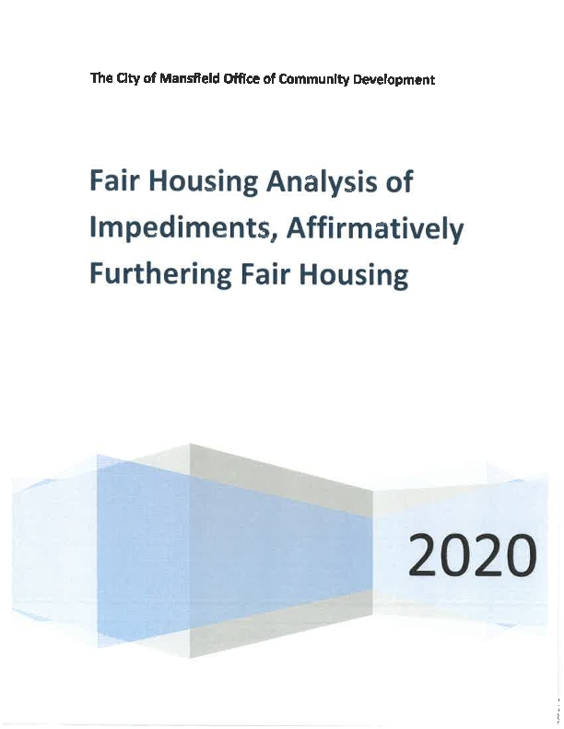
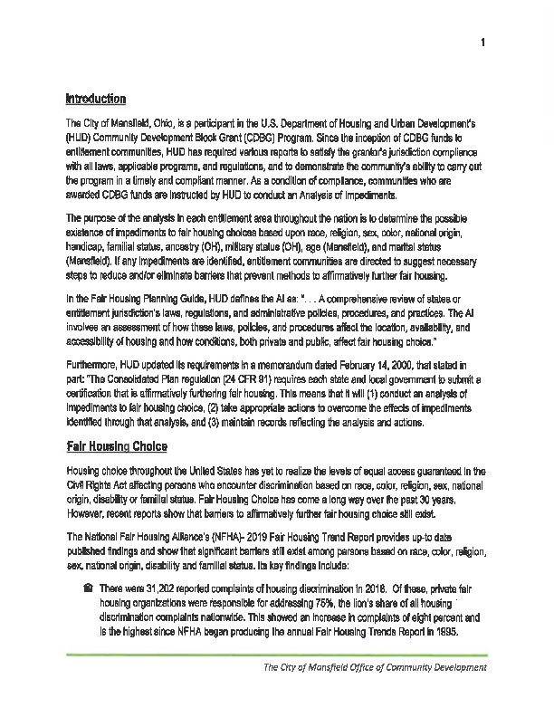
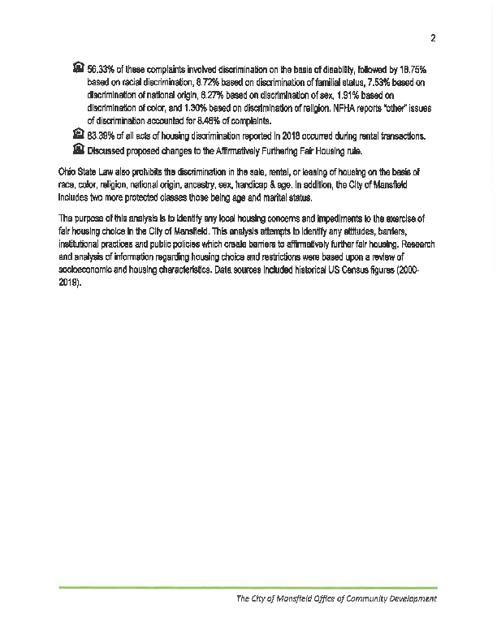
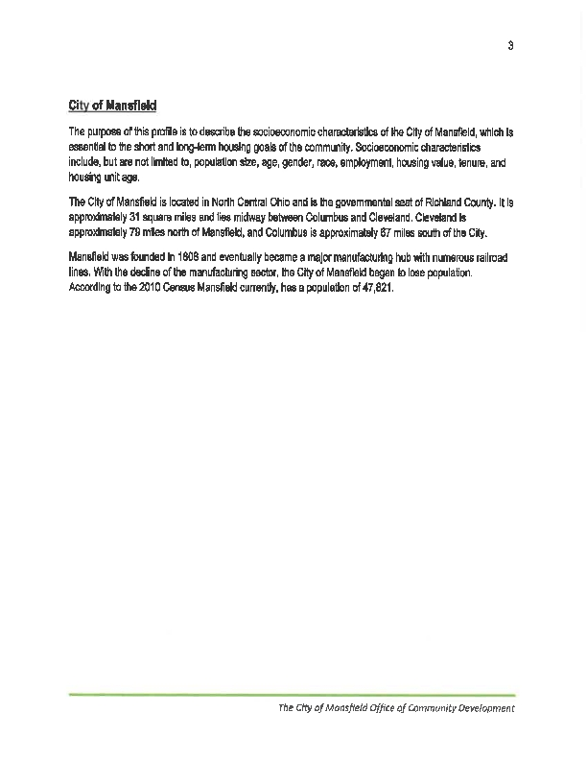
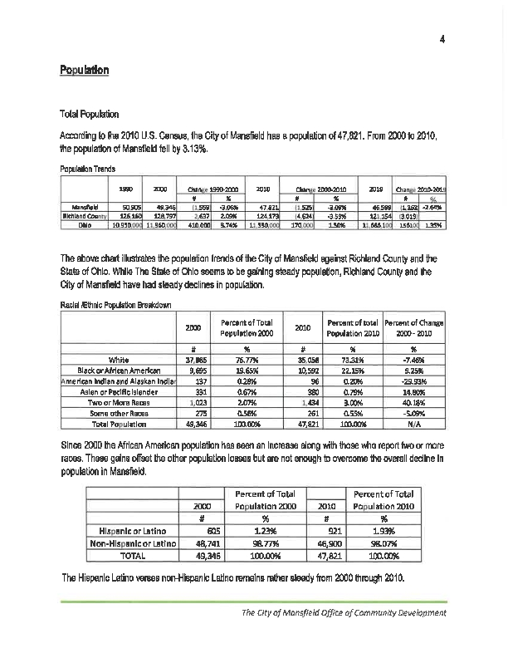
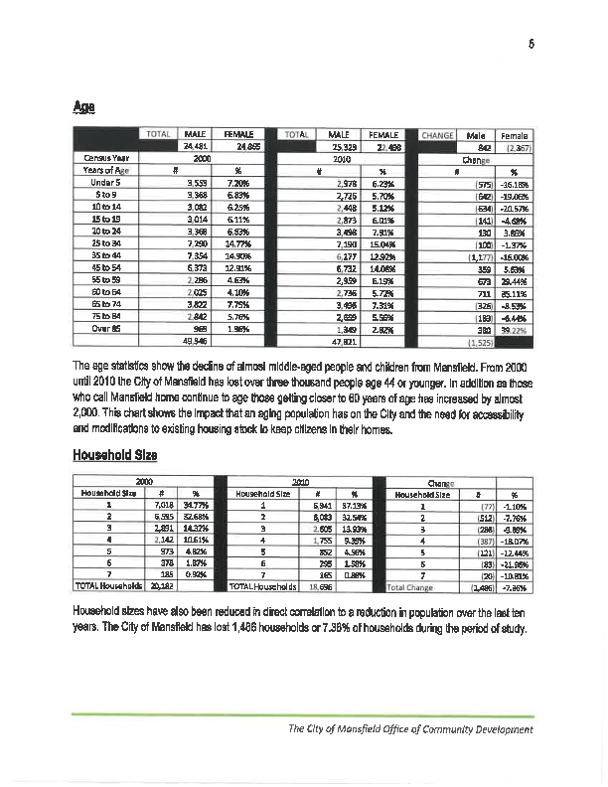
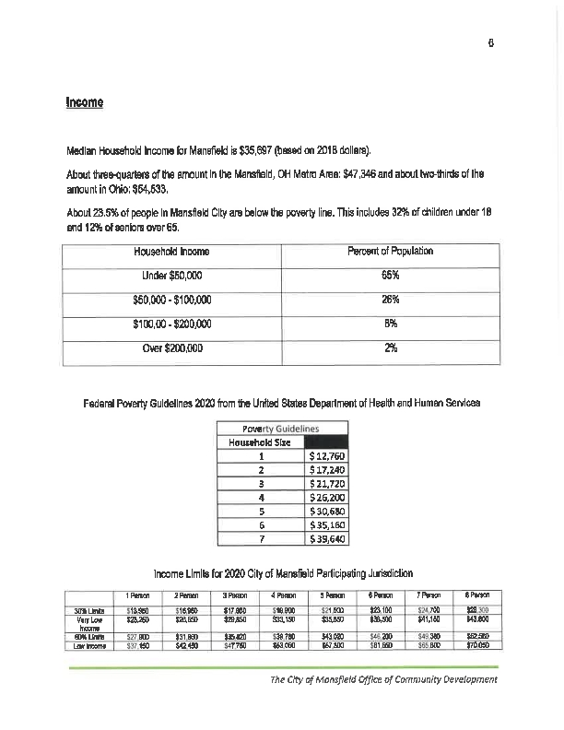
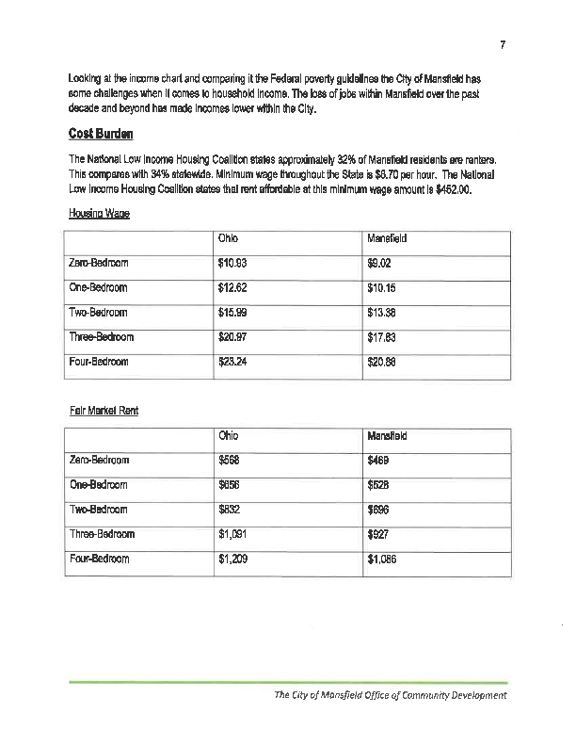
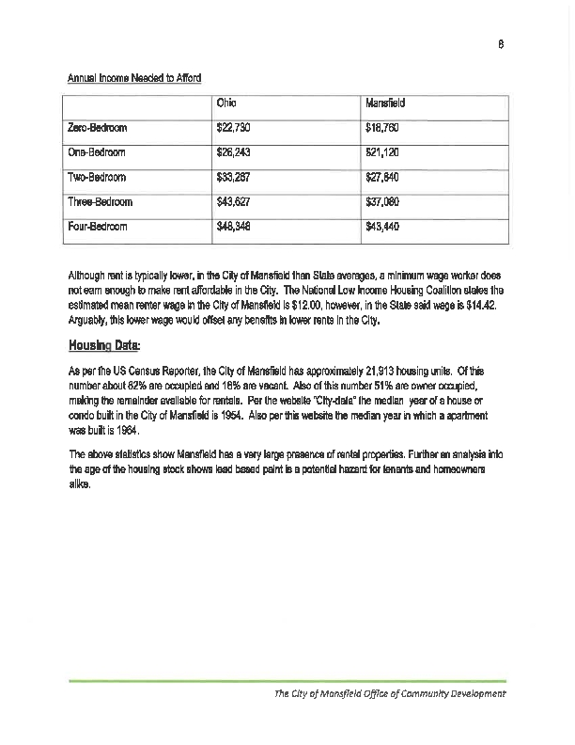
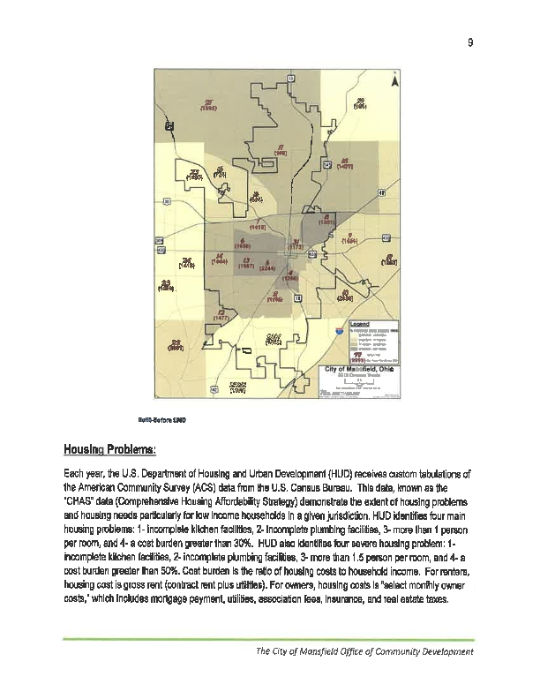
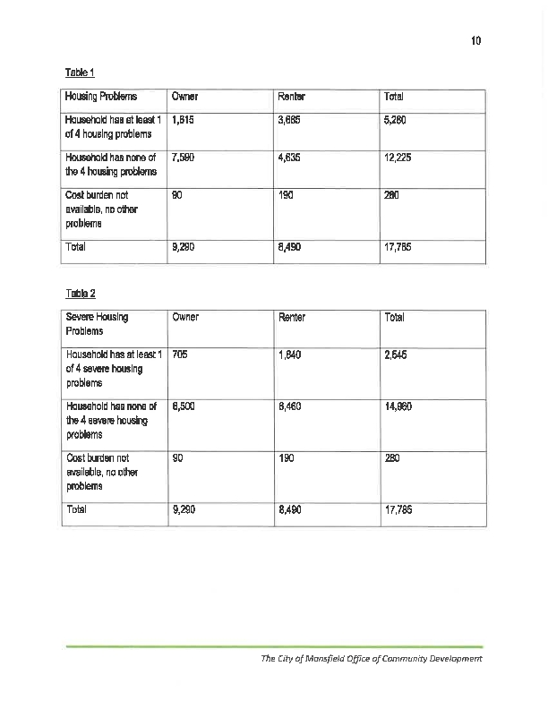
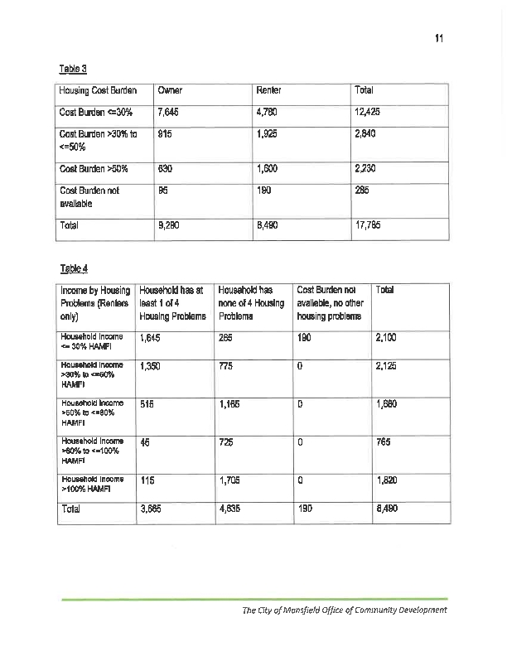
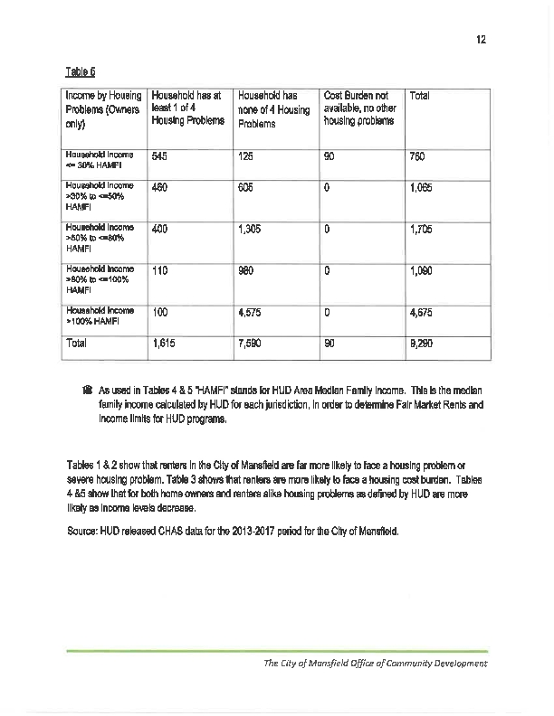
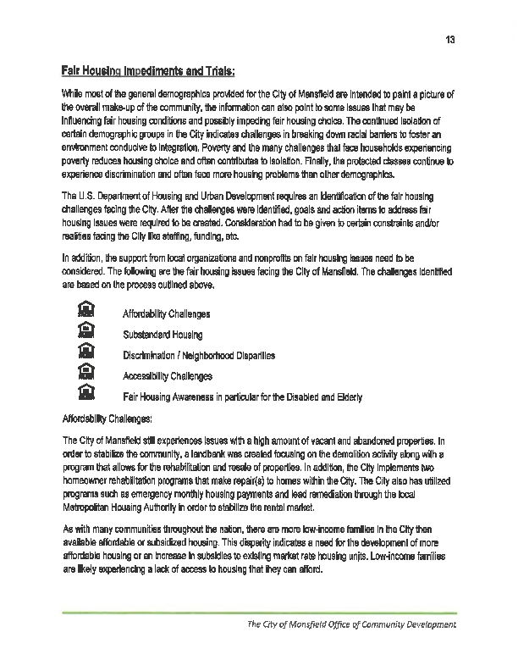
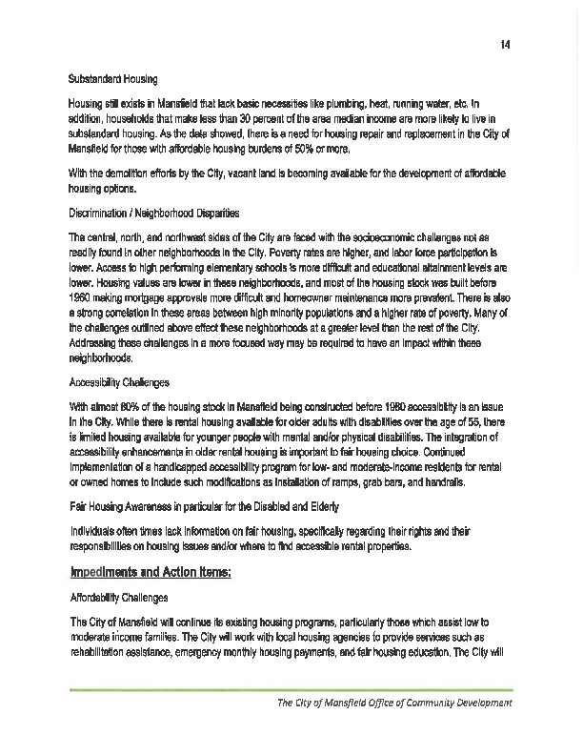
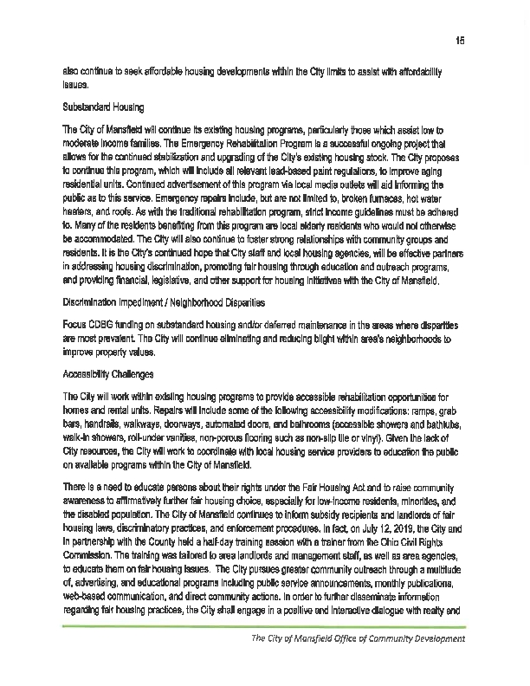
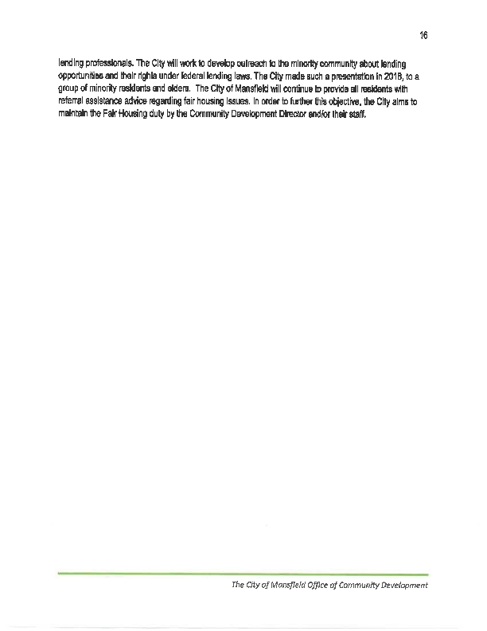
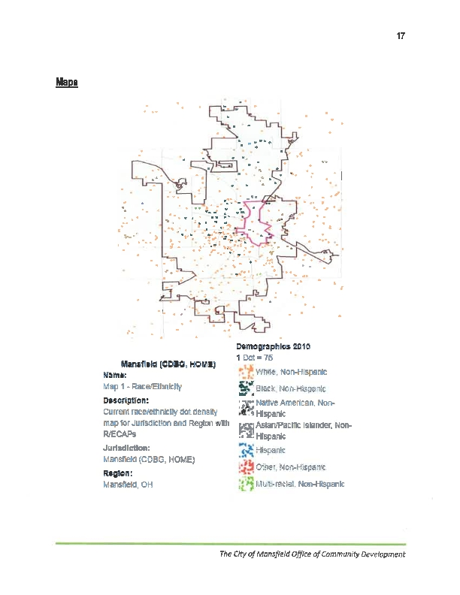
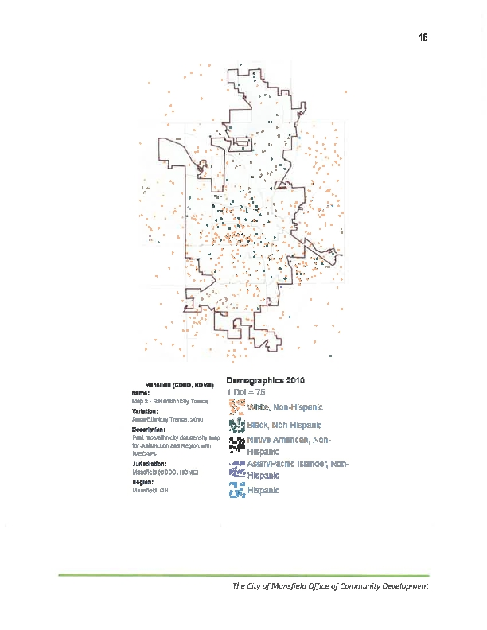
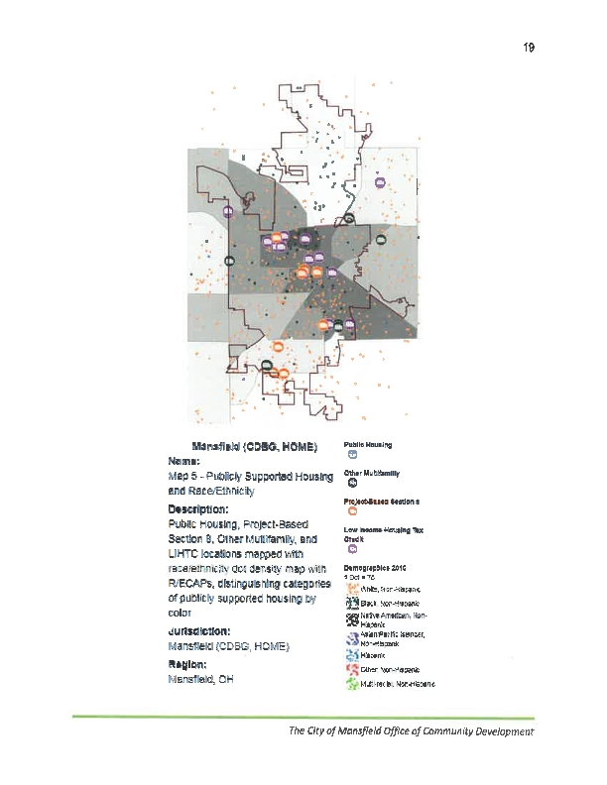
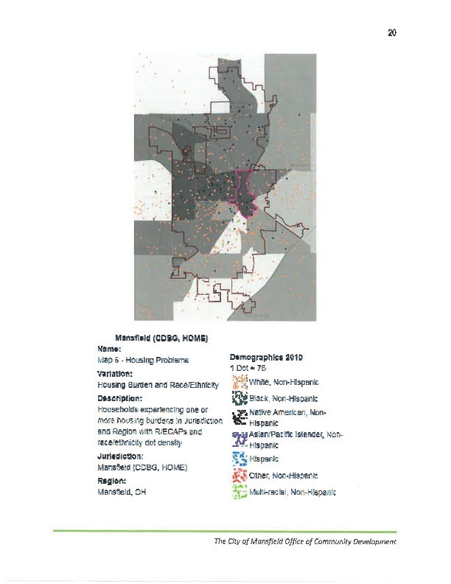
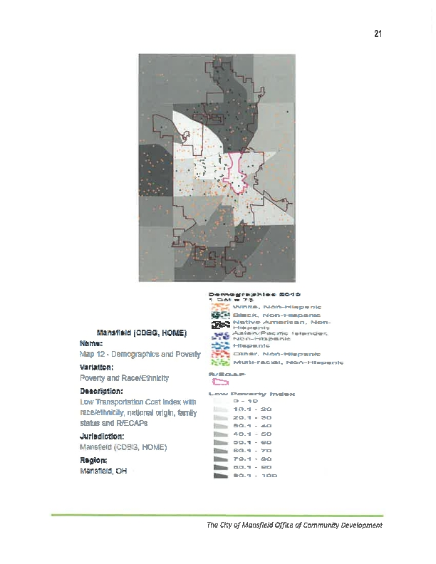
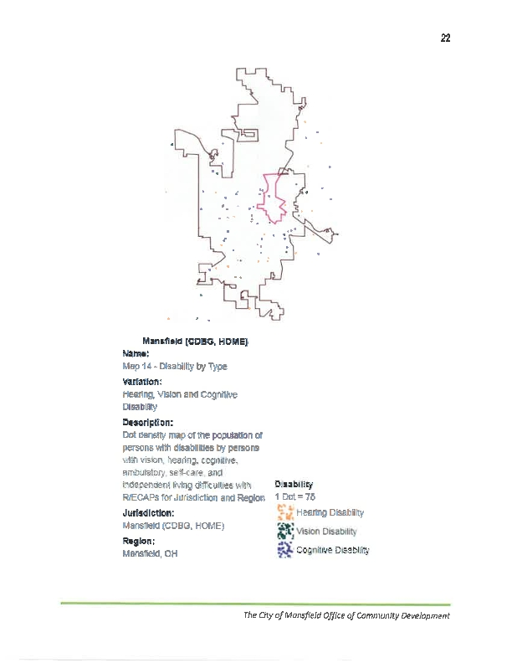
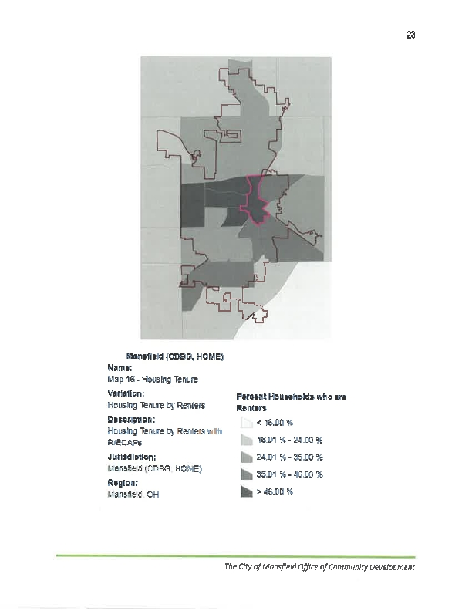
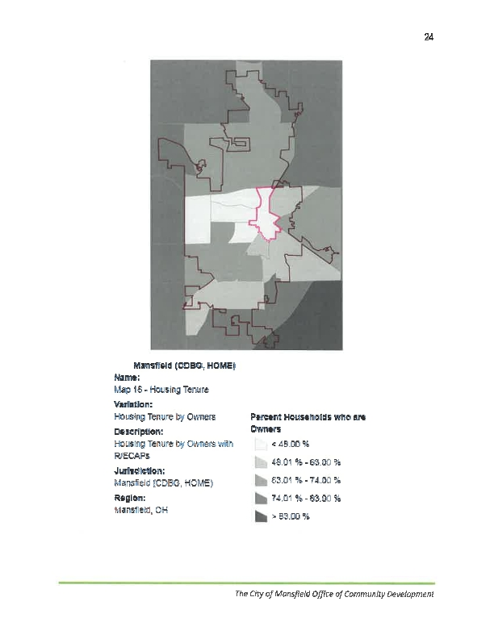

PR-03 BOSMAC
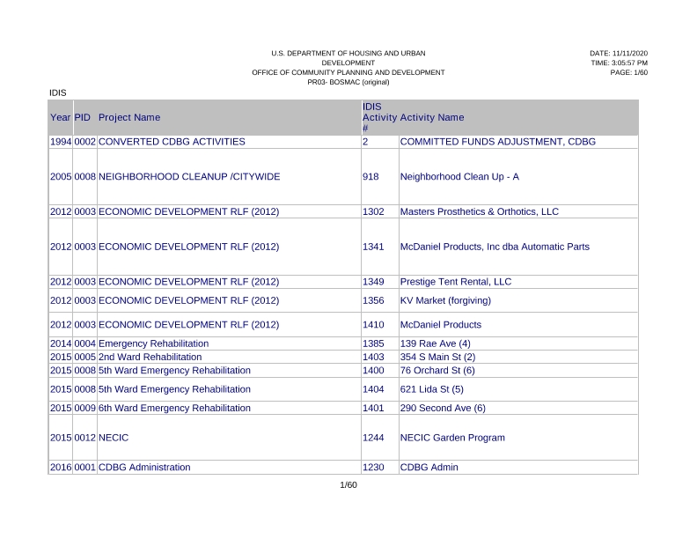
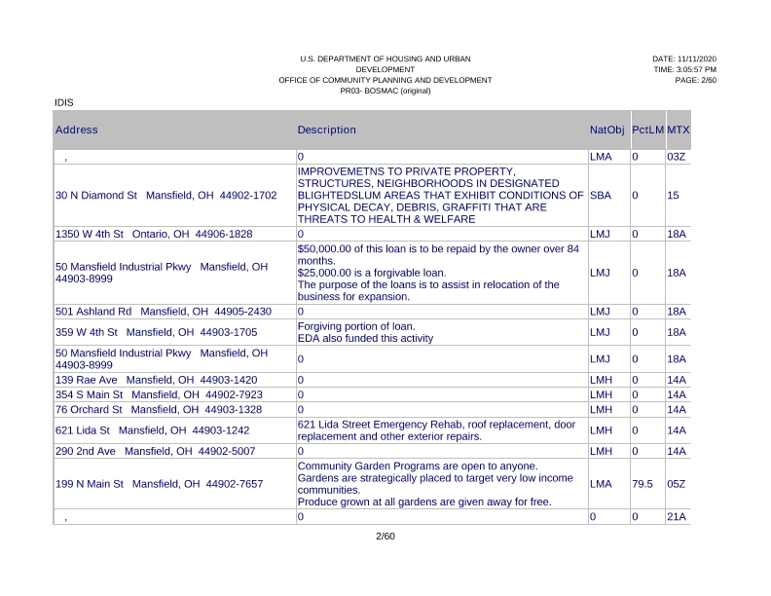
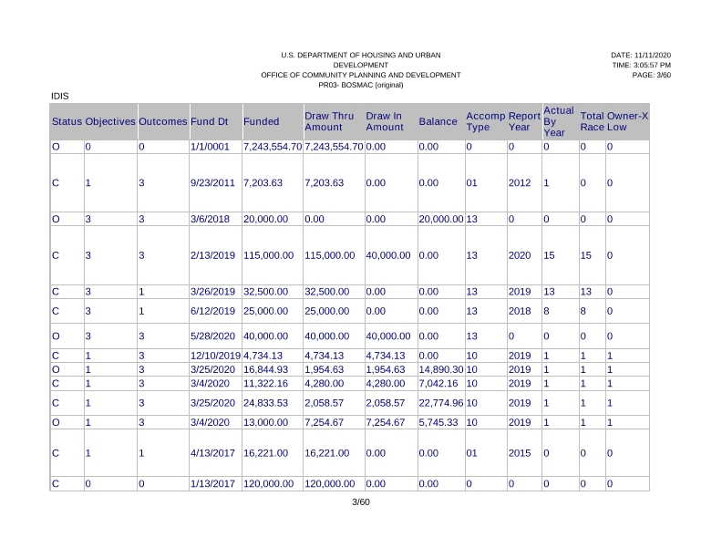
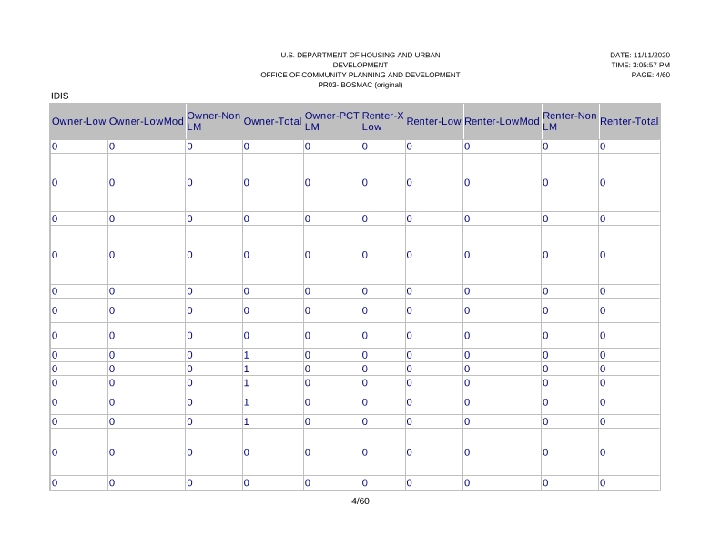
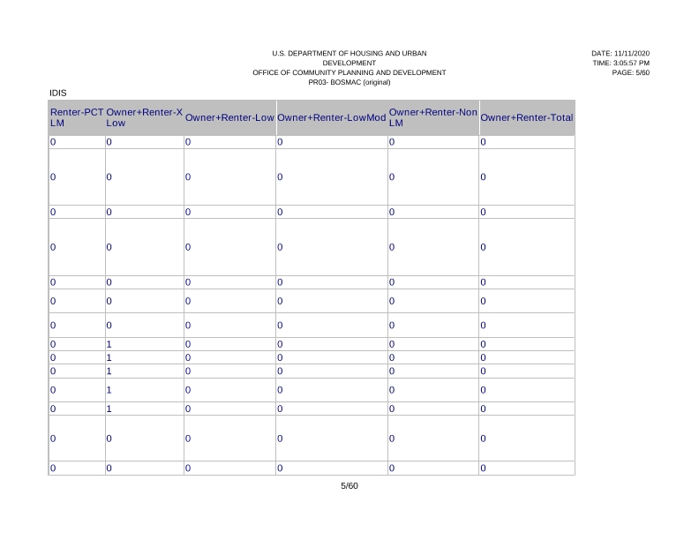
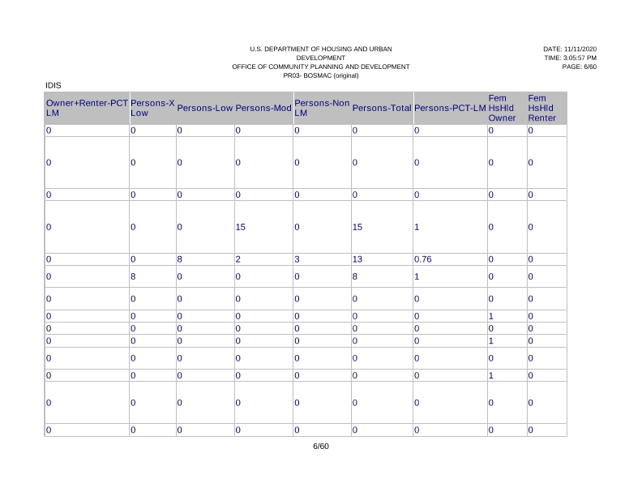
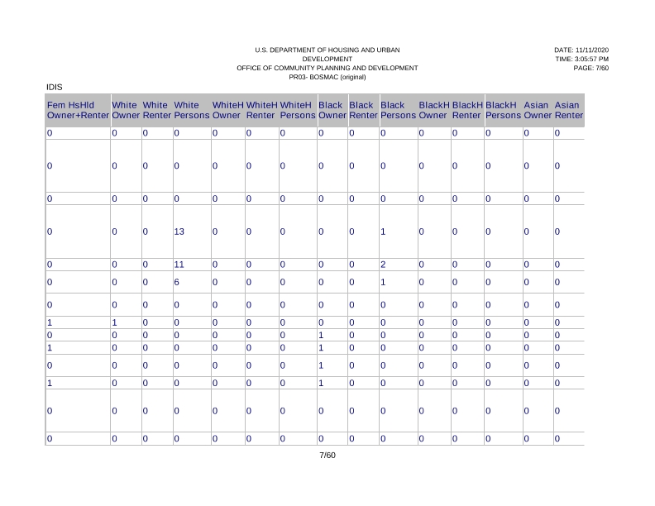
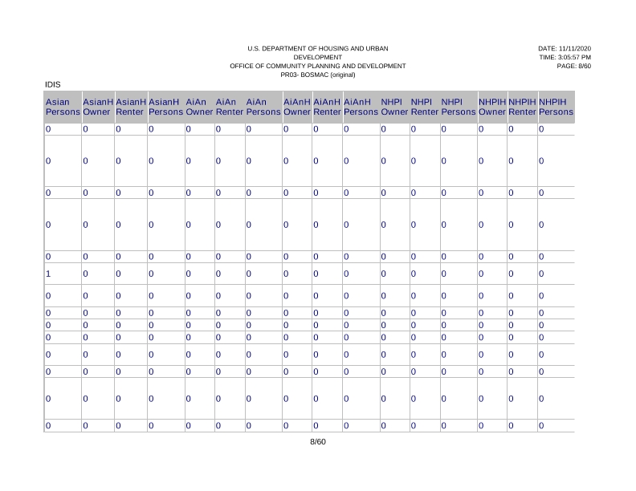
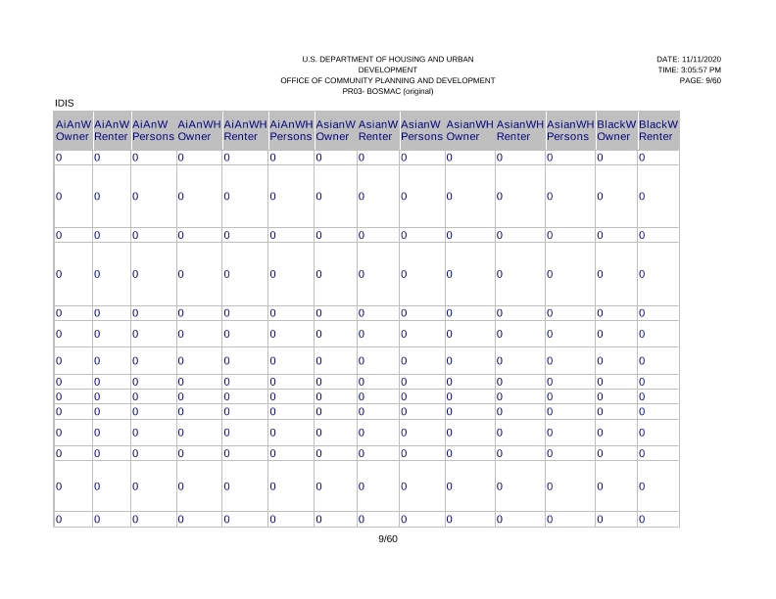
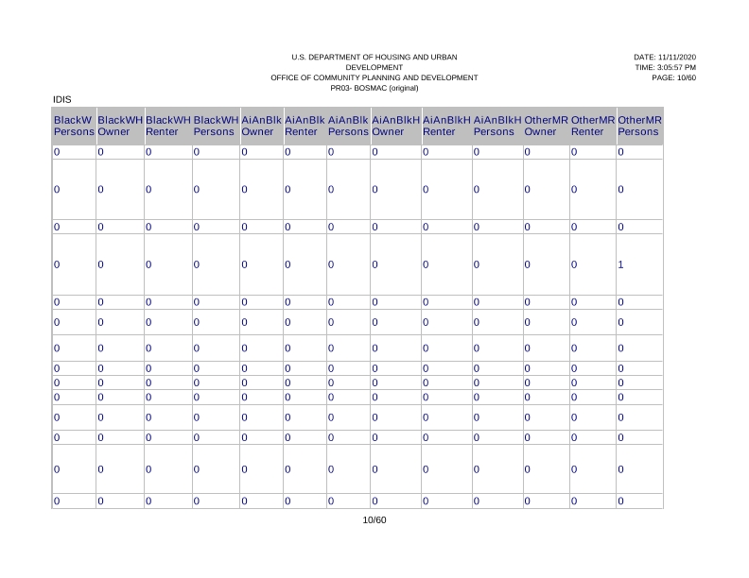
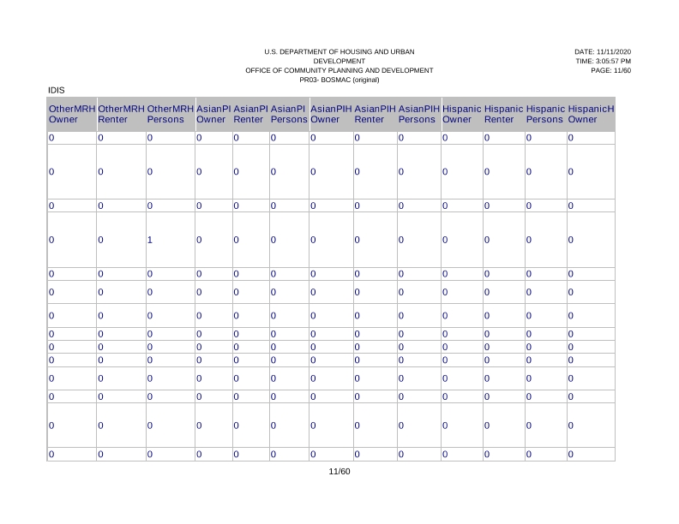
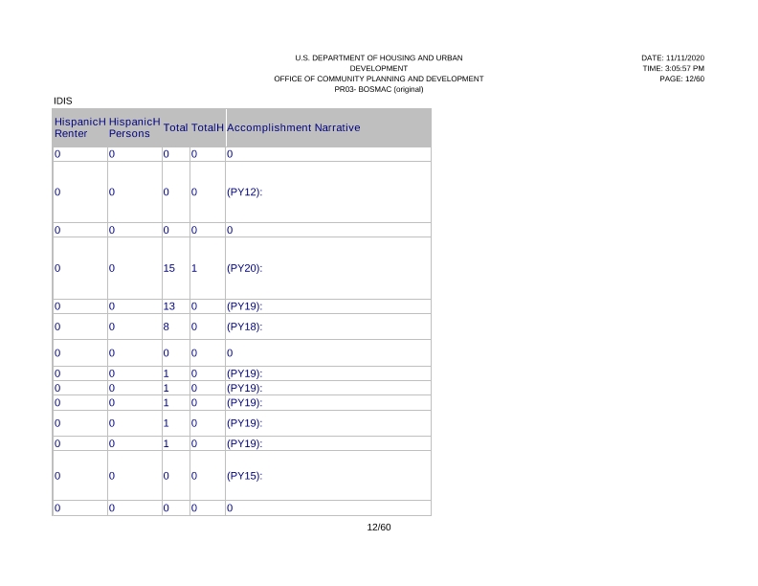
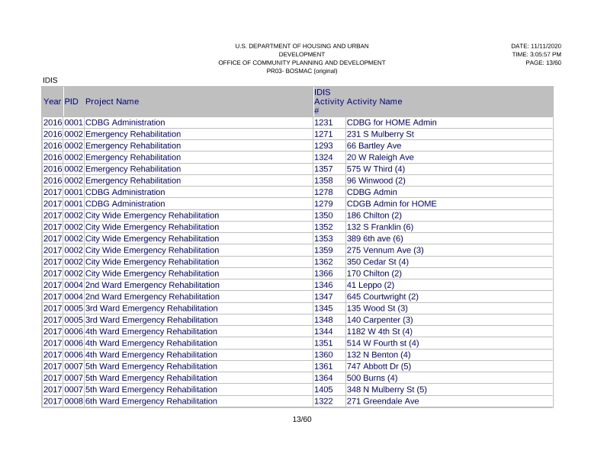
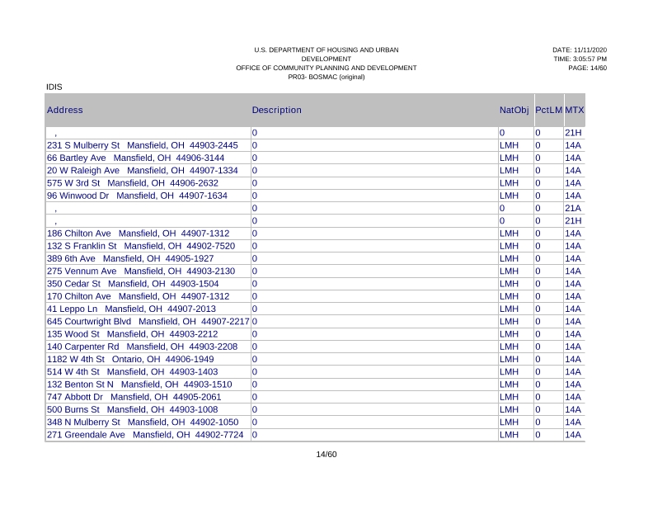
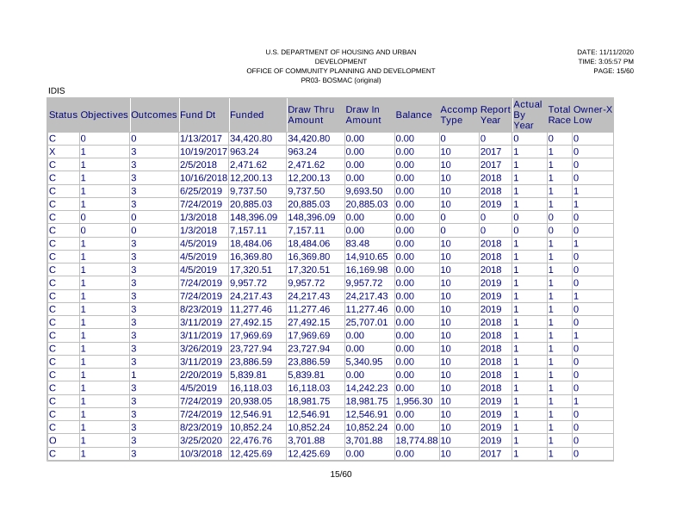
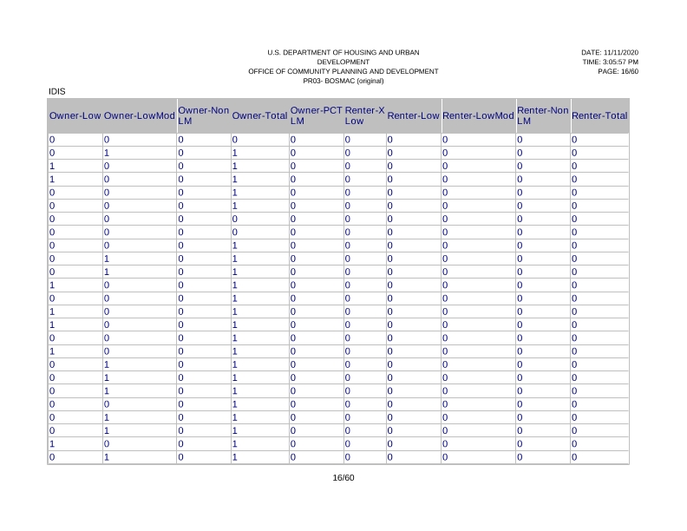
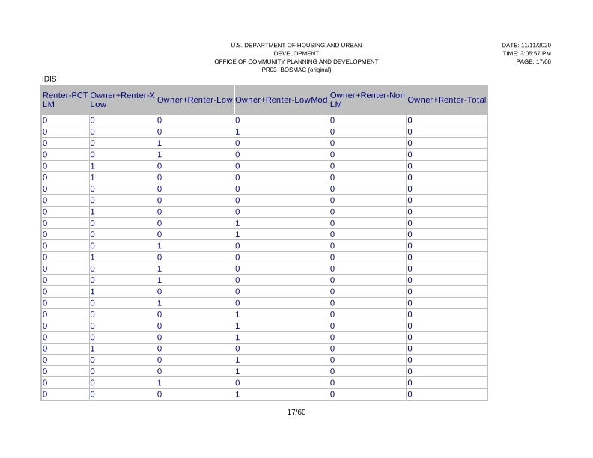
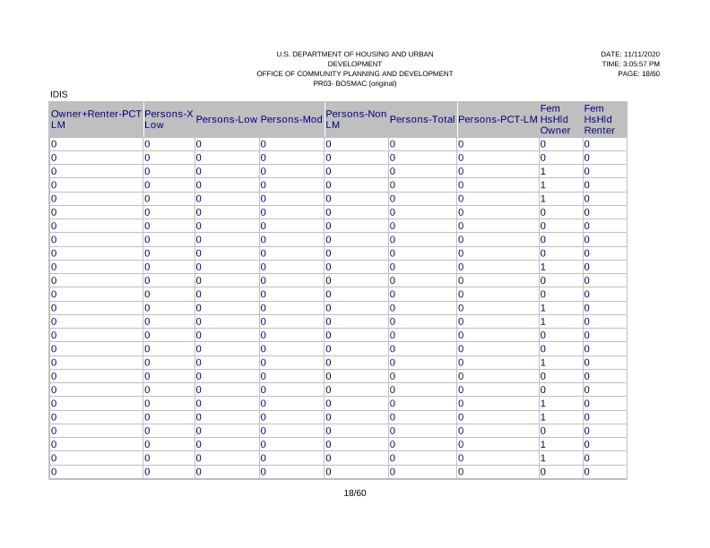
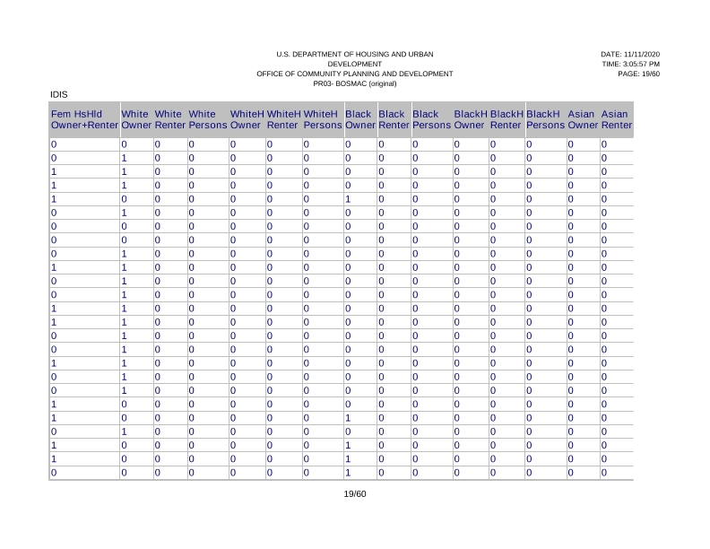
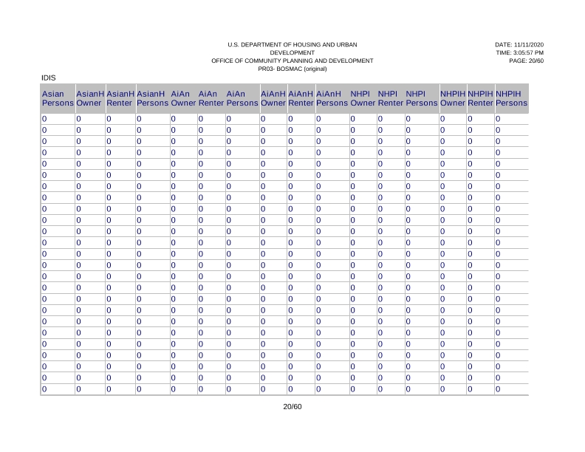
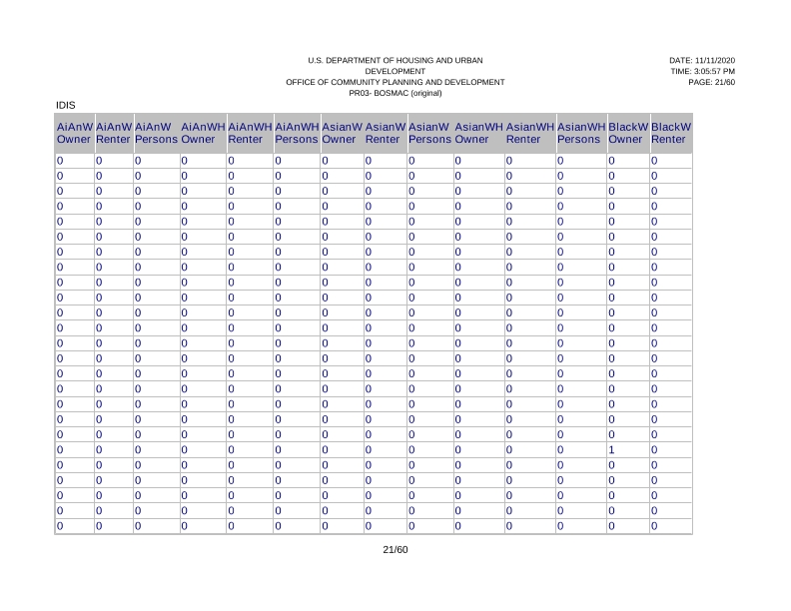
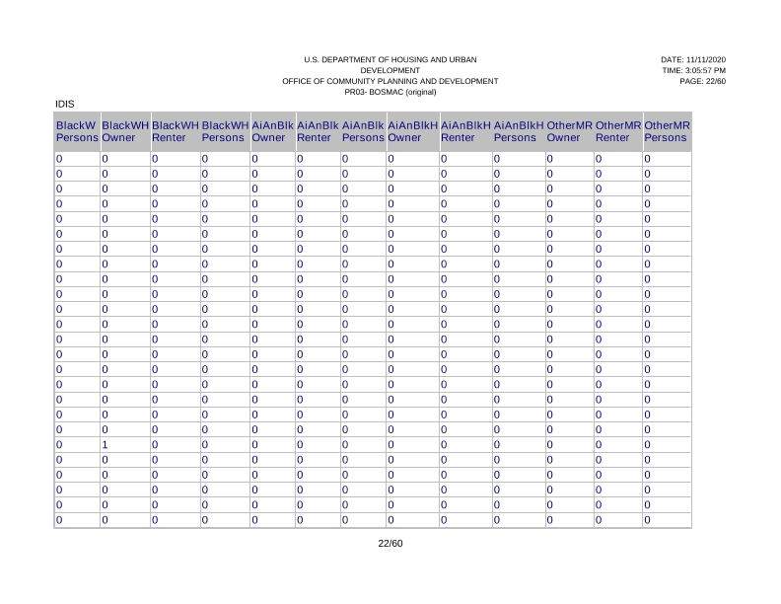
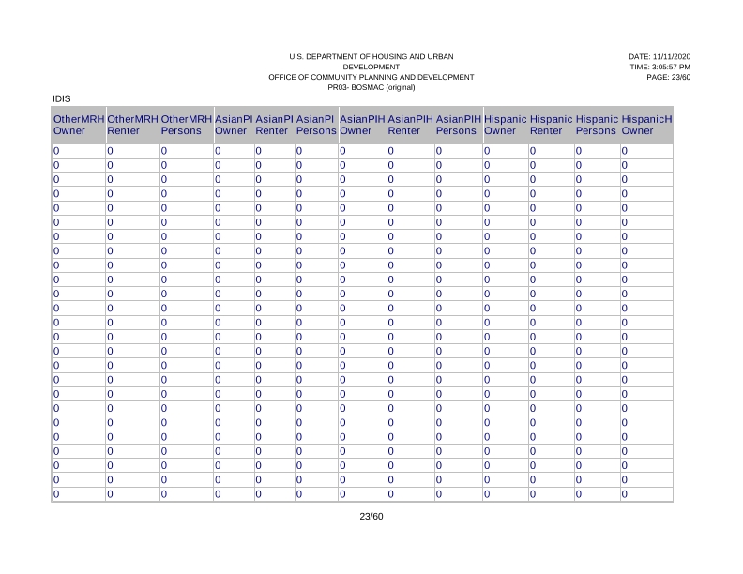
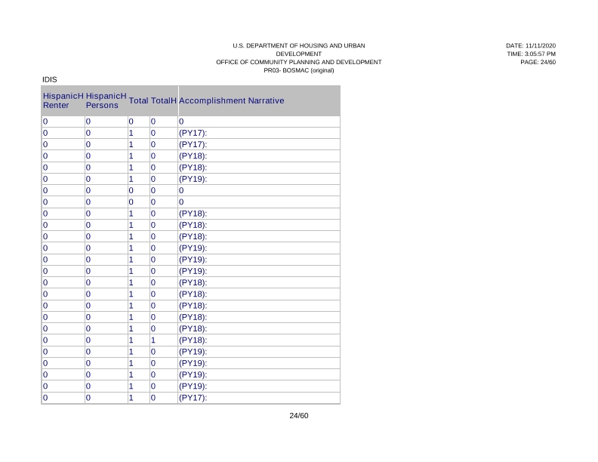
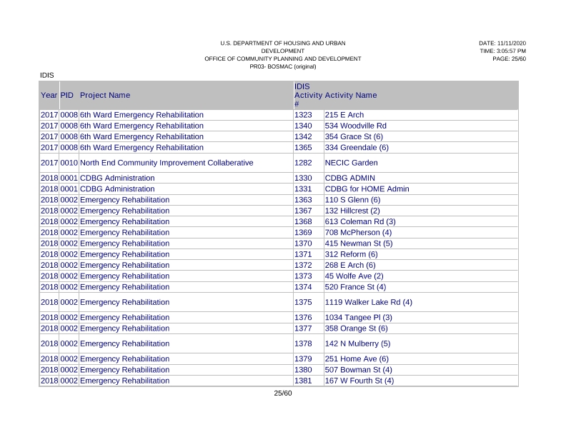
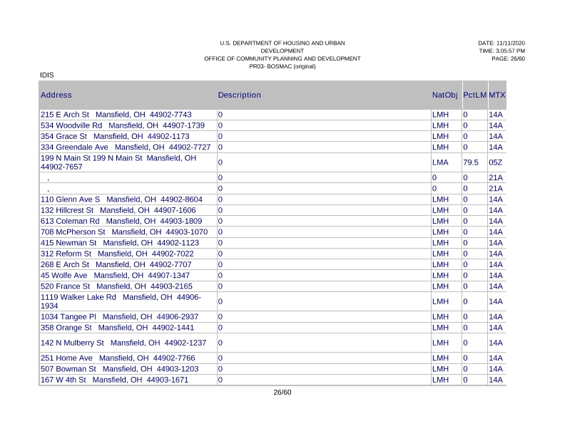
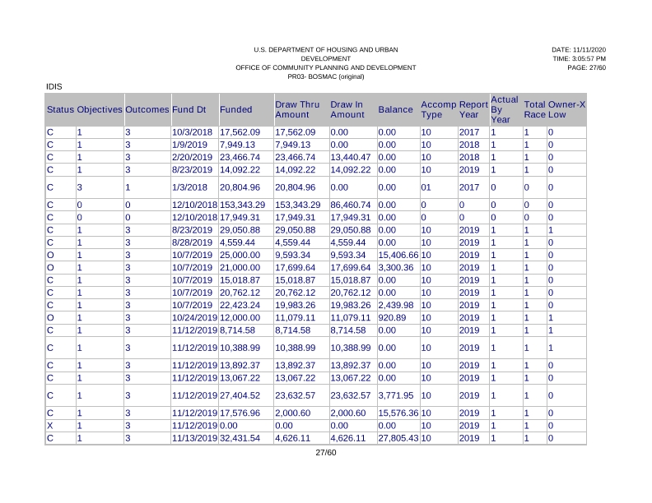
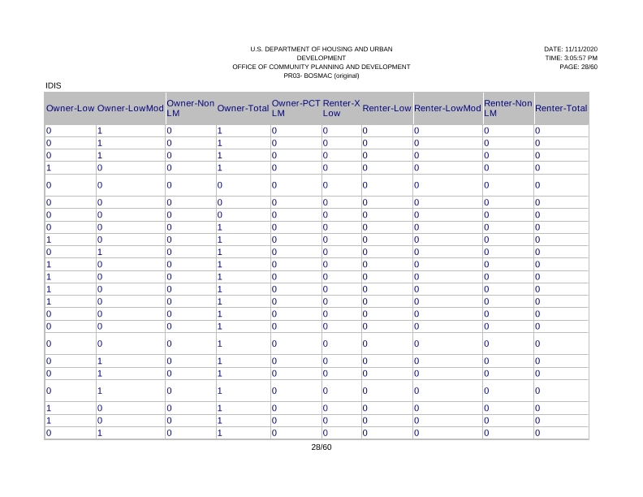
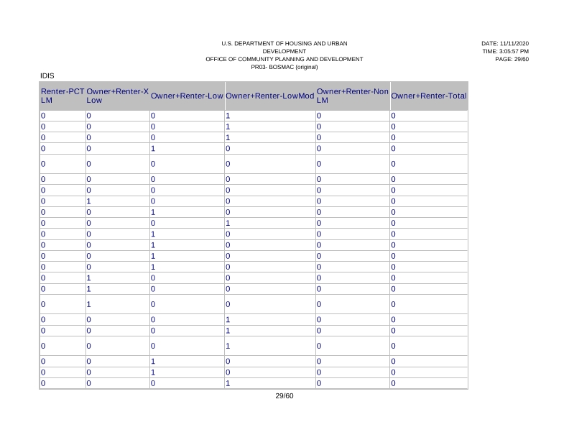
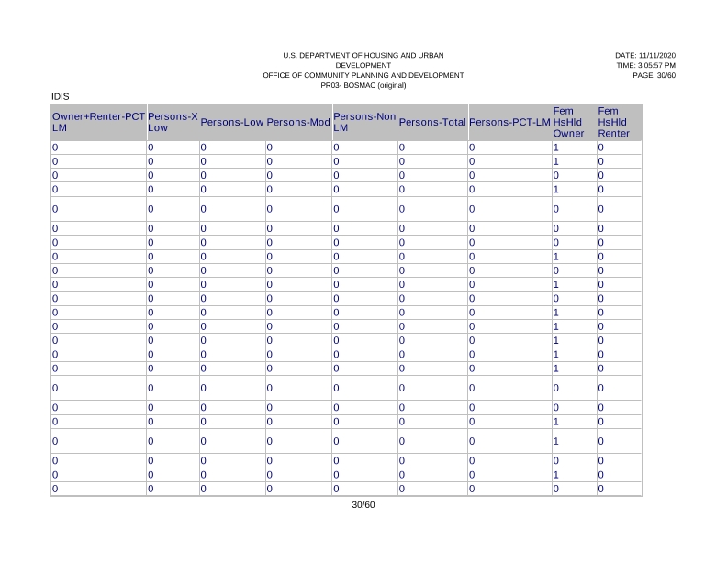
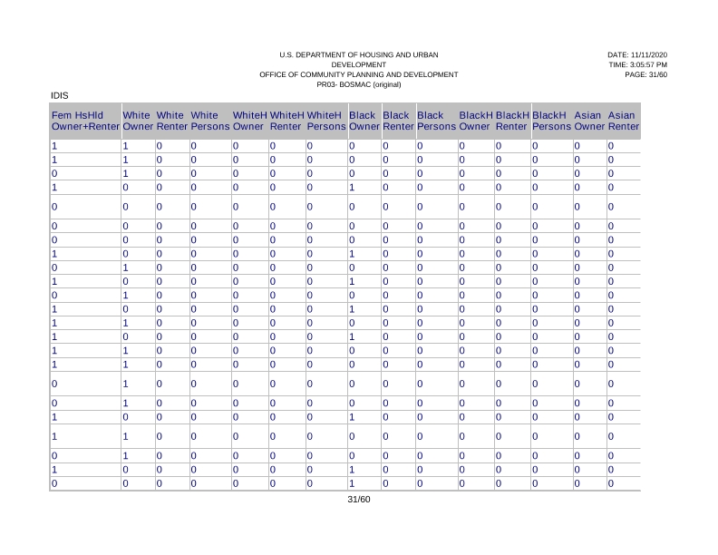
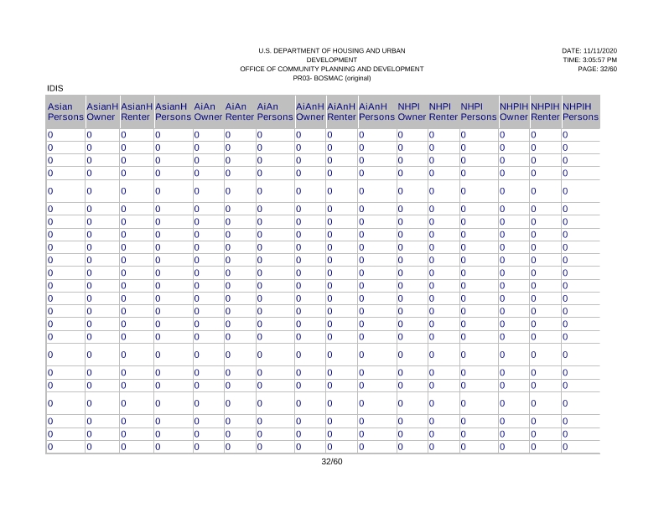
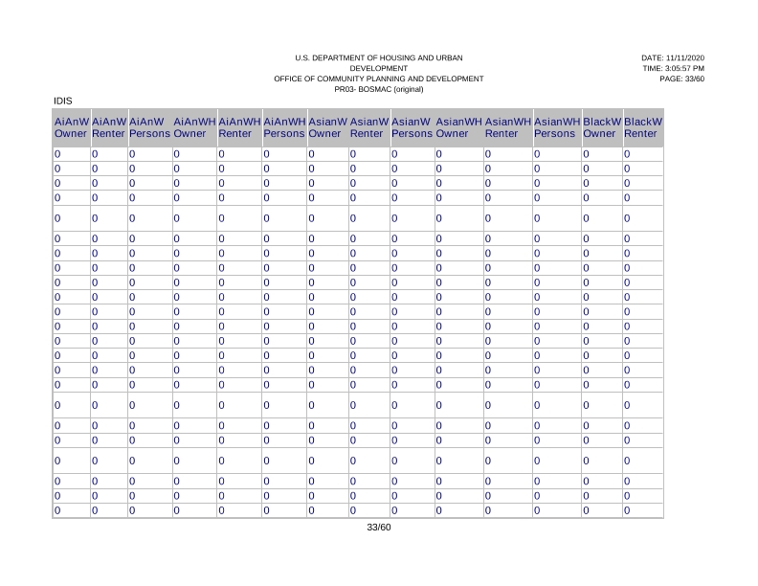
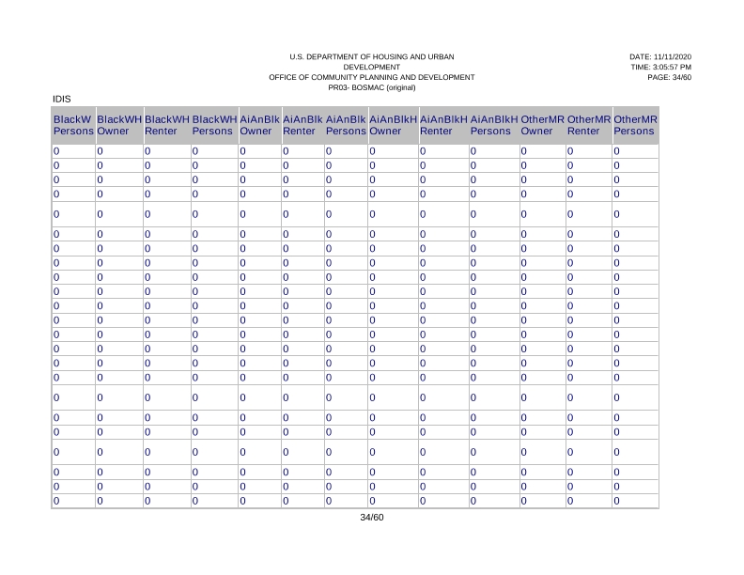
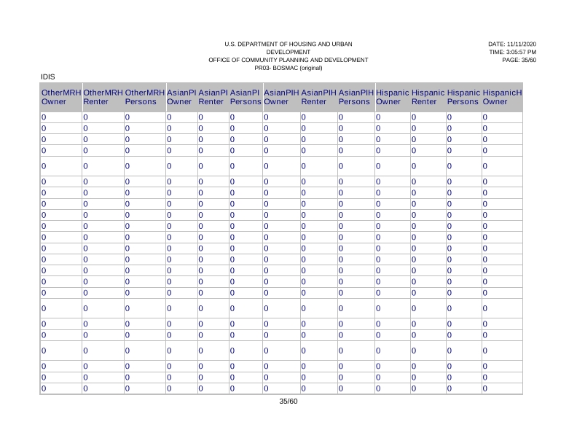
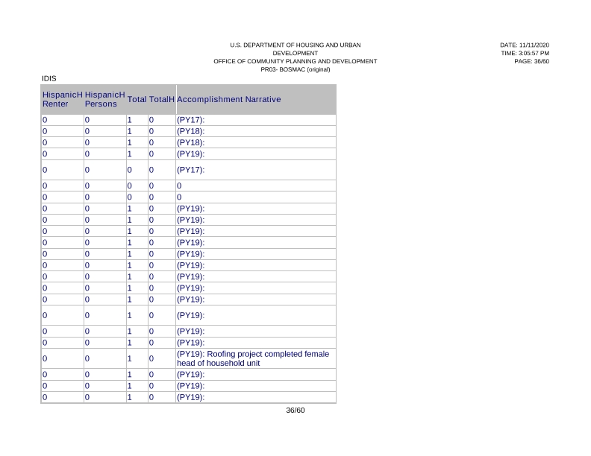
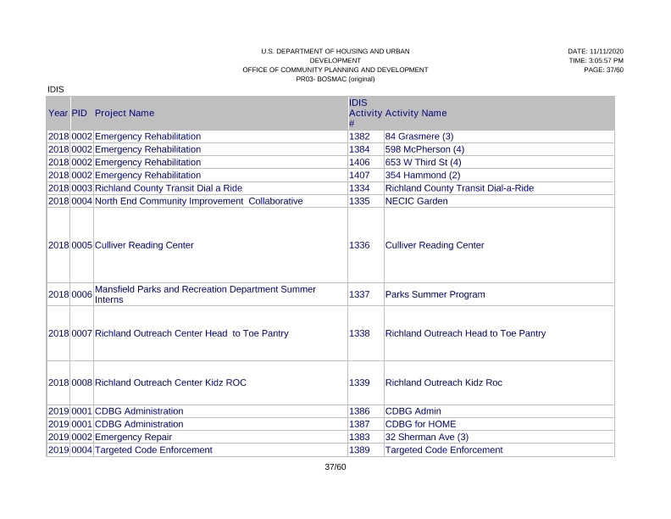
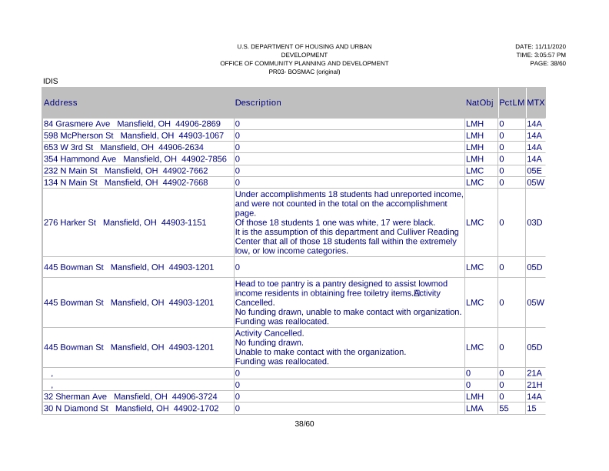
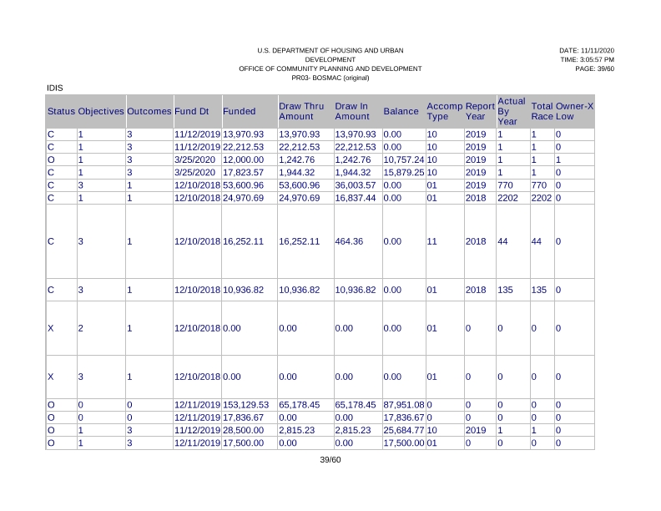
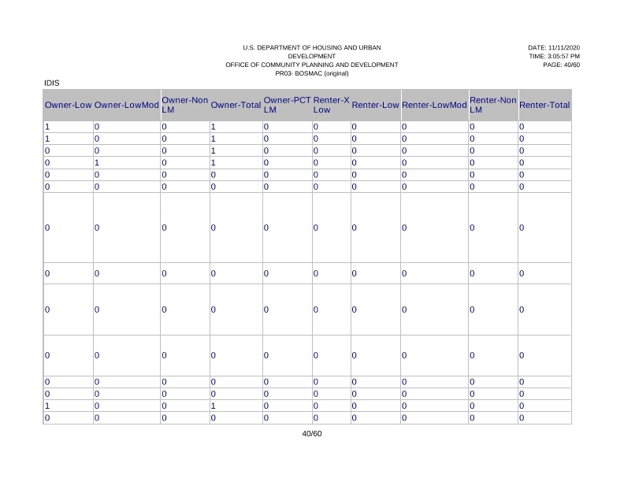
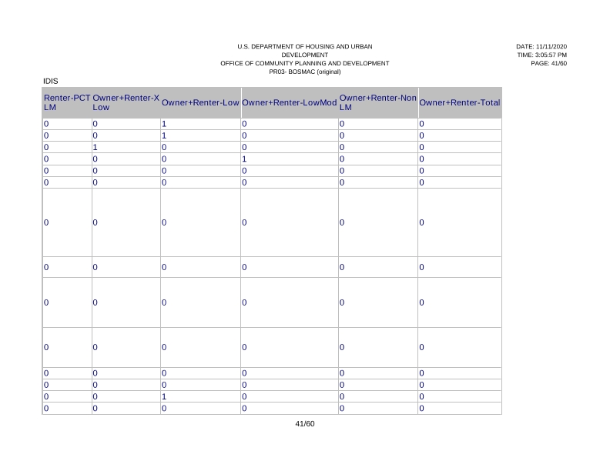
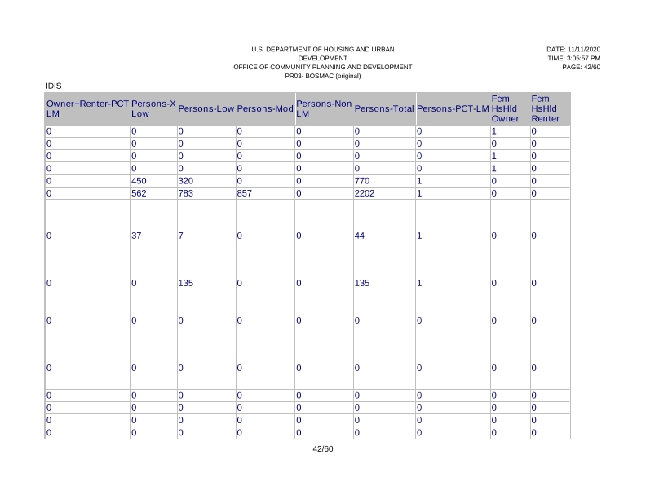
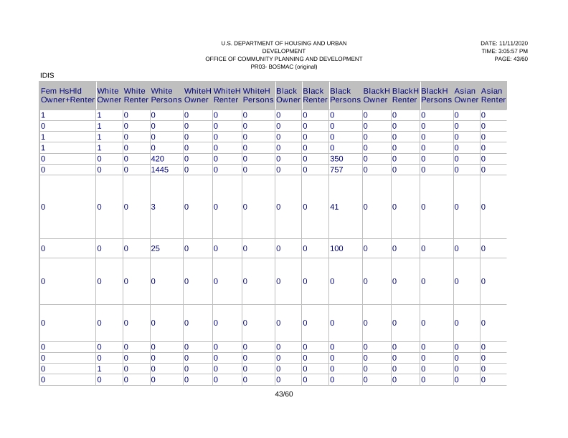
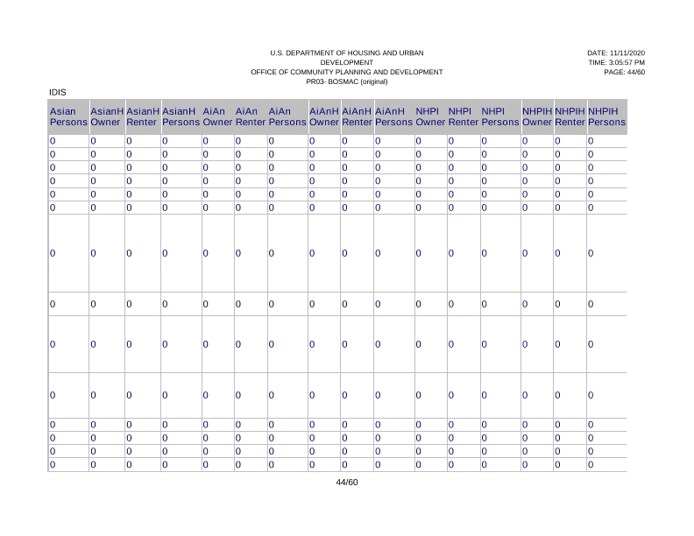
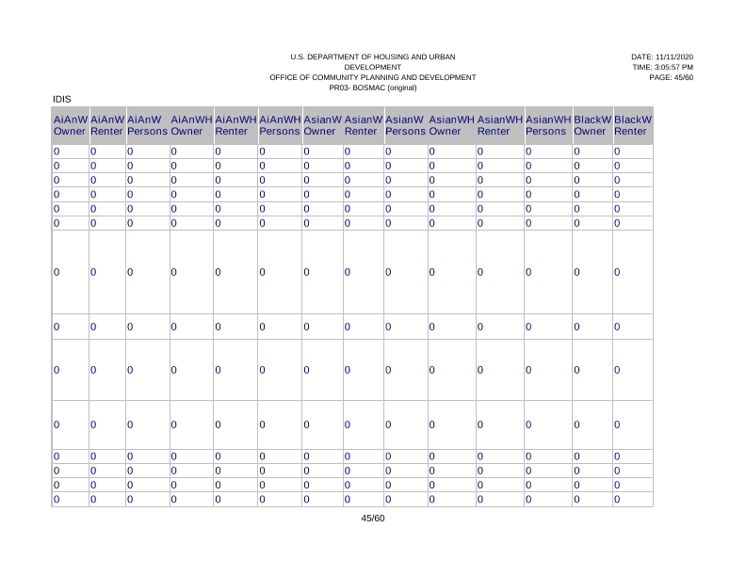
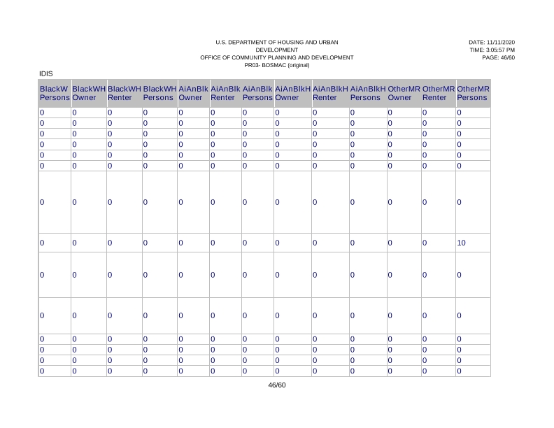
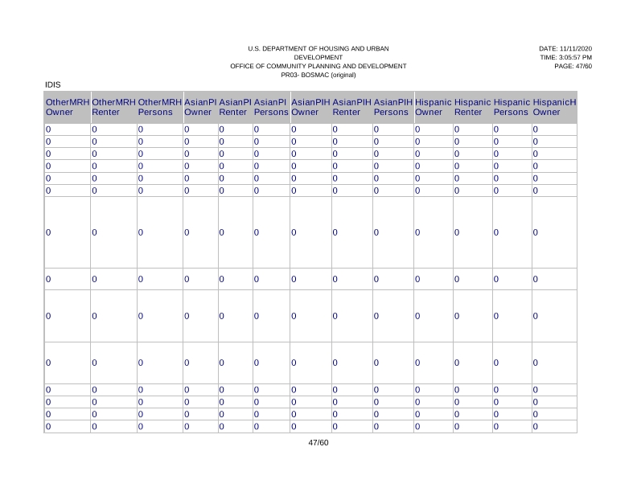
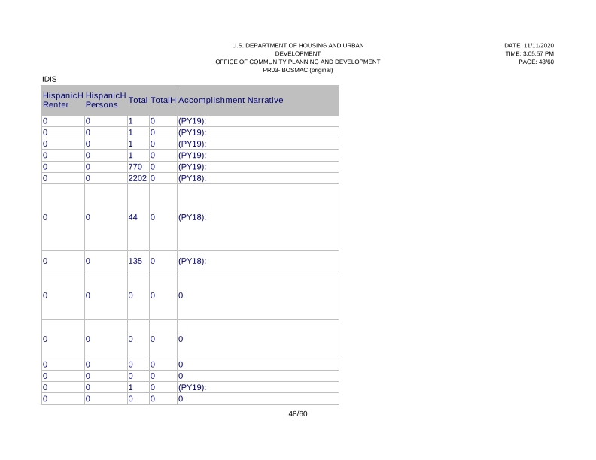
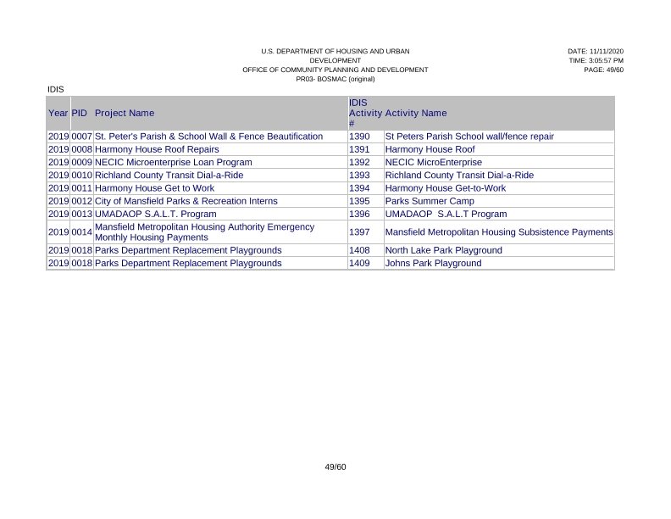
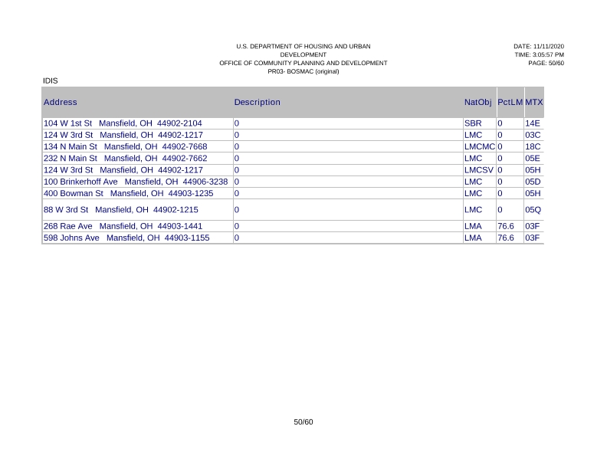
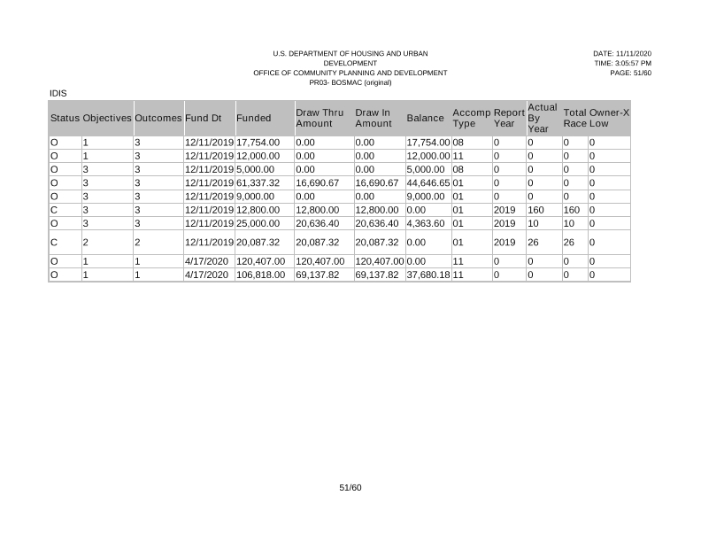
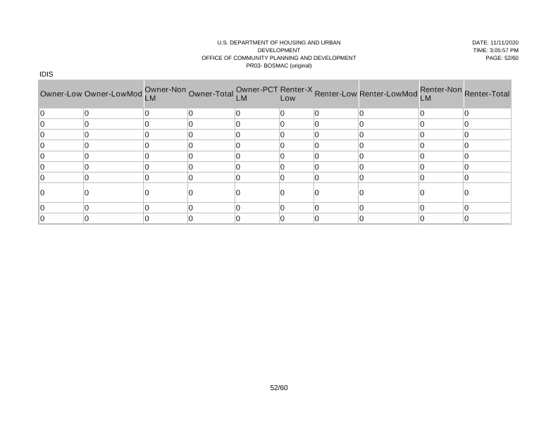
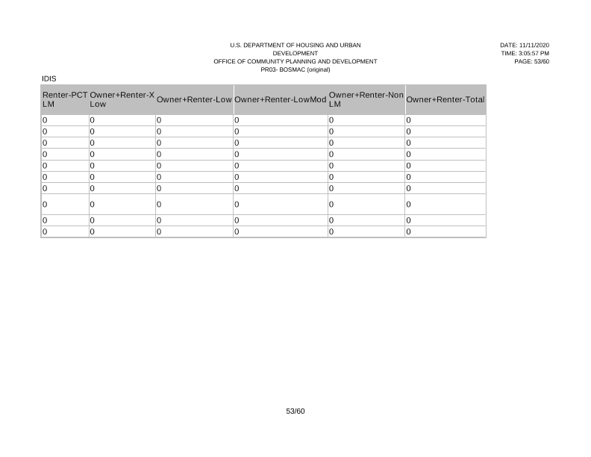
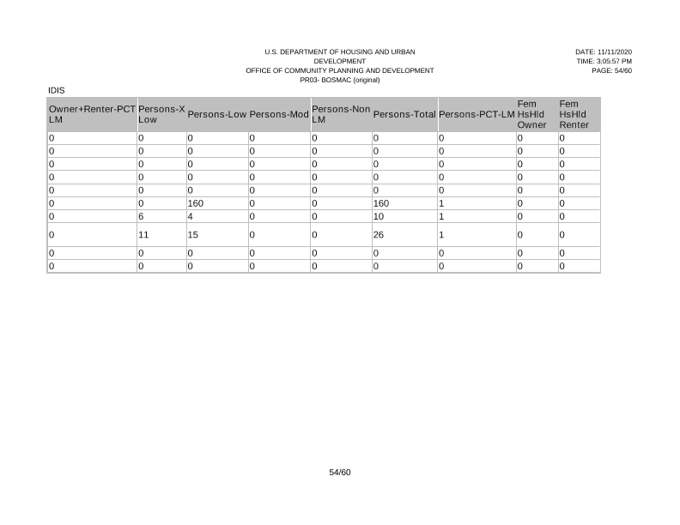
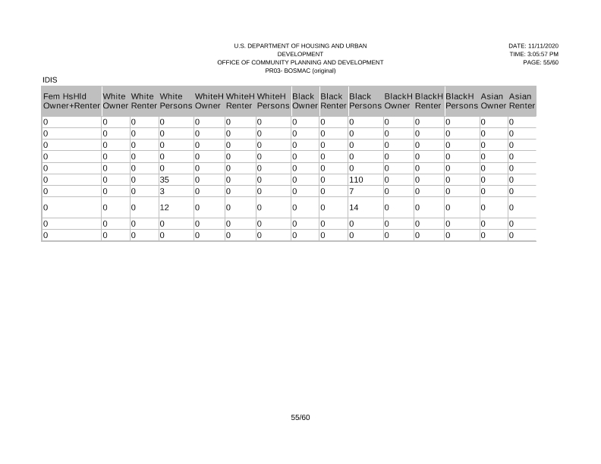
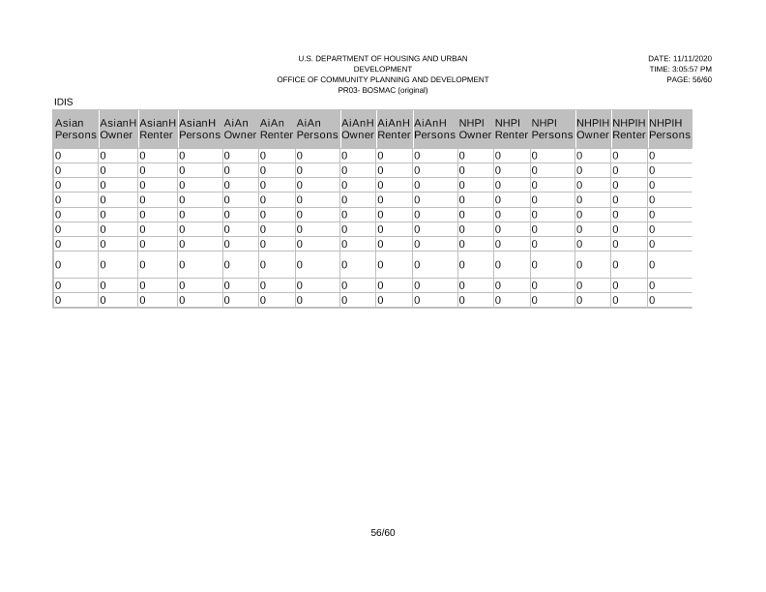
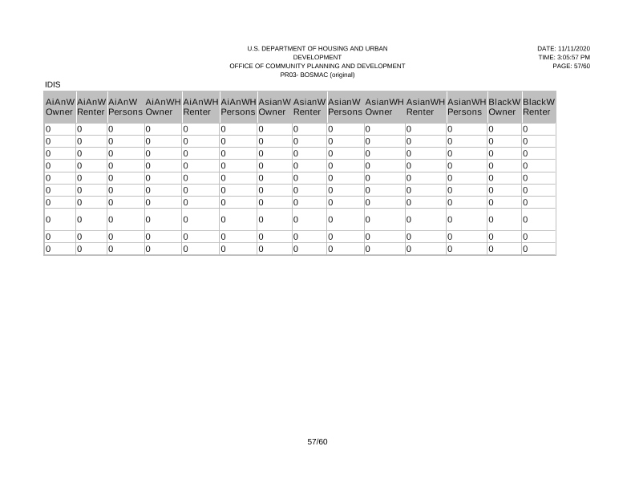
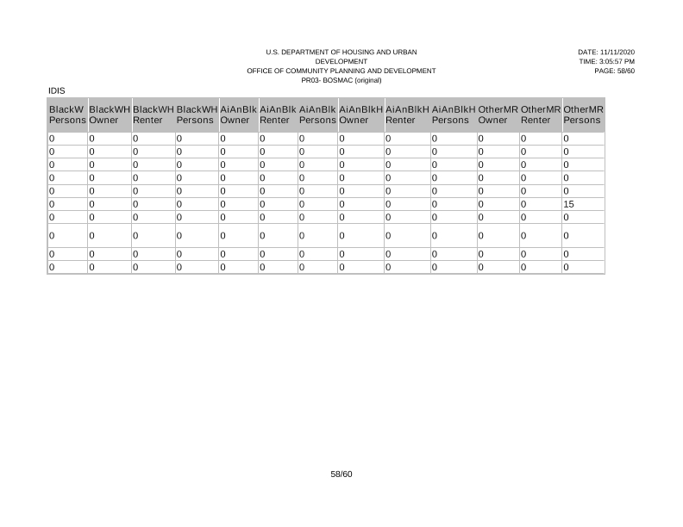
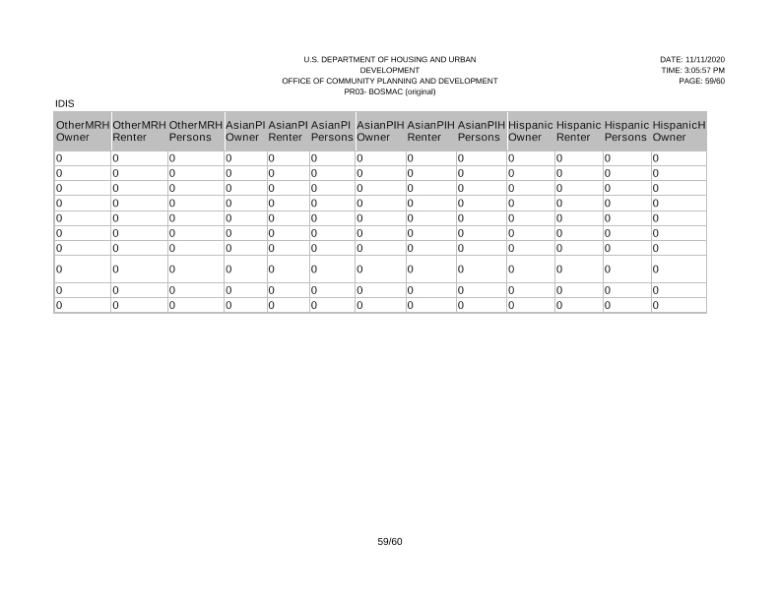
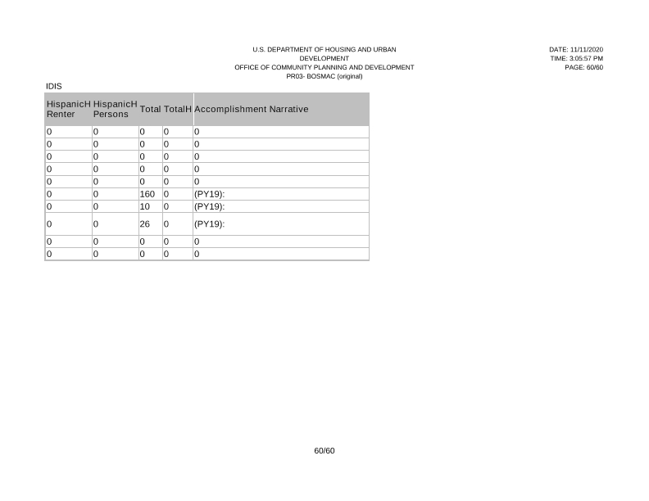

PR 26
